Veal Fine CO2 Reduction Plan  
Business case 3

**Veal Fine CO2 Reduction Plan**

**Business Case 3**

**Chantal Knopper (498985)**

**Jan Younan (494922)**

**Nadia Lufting (501963)**

**Romario Younan (494921)**

**Rowan van Munster (489906)**

**Trang Phan (487138)**

**(Business Case: Group 2, Class DIB2V.A)**

**Saxion University of Applied Sciences**

**Deventer, the Netherlands**

**Business Coach: Mrs. M. van Nuil**

**17 January 2022**

# **Preface**

Before you lies the dissertation ‘’Veal Fine CO2 Reduction Plan’’, the basis of the ecological footprint that was counselled for Veal Fine. It has been written to fulfil the graduation requirements of the International Business Studies at the Saxion University of Applied Sciences. Individuals involved were engaged in researching and writing this dissertation from August (2021) to January 2022.

The project was undertaken at the request of Veal Fine. The research question was formulated at request of the company and lecturers, Mrs. M. van Nuil and Mr. M. Slootweg. The research has been conducted with the use of extensive investigation. It has been adjusted to take into account the changes that have occurred over the recent years in the meat (consumption) market.

We could not have achieved the current level of success and explicit recommendations without any support. Thank are due our business case coach Marleen van Nuil and lecturer Marcel Slootweg for providing us with information and weekly feedback. Secondly, we want to thank Mark van Roekel, communication manager at Veal Fine, for giving us this business case and trusting us with the company’s confidential information. Lastly, we would like to thank the group members for motivating each other throughout the project and applying critical thinking to this business case.

We hope you enjoy your reading.

Chantal Knopper, Jan Younan, Nadia Lufting, Romario Younan, Rowan van Munster and Trang Phan

Deventer, 16 January 2022

**Table of Contents**

**Preface**

**List of Figures and Tables**

**Management Summary** 1

**Explanation of Terms** 2

**1.** **Introduction** 3

**2.** **Theoretical framework** 4

2.1 Framework of CO2 calculation Veal Fine 4

2.2 GHG emissions livestock 5

2.3 GHG emissions transport 6

2.4 GHG emissions utilities 6

**3.** **Methodology** 7

**4.** **Internal analysis** 9

4.1 Mission, vision and strategic goals 9

4.2 Company structure 9

4.3 Internal stakeholders 10

4.4 Customer analysis 11

4.4.1 Customer persona and buying process 11

4.5 Market share 13

4.6 Cost structure 13

4.7 Supply chain 14

**5.** **External analysis** 16

5.1 (Veal) meat consumption market 16

5.2 External stakeholders 16

5.3 Benchmarking the competitive environment 17

5.3.1 Competitor analysis 18

**6.** **SWOT analysis** 20

**7.** **CO2 Calculation - Emissions per sector** 22

7.1 Carbon dioxide and methane 22

7.2 Footprint in the livestock sector 22

7.3 Footprint in the transportation sector 24

7.4 Impact of utilities 24

**8.** **Conclusion** 27

**9.** **Sustainable alternatives for Veal Fine** 28

9.1 Livestock sector 28

9.2 Transportation 29

9.3 Utilities 30

**10.** **Implementation** 32

10.1 Management and organisation 32

10.2 Marketing and sales 32

10.3 Finance 33

10.4 Planning 35

**11.** **Group reflection** 35

11.1 Individual group reflection 36

**Bibliography** 39

**Appendix I – CO2 Calculations Veal Fine** 52

**Appendix II – Energy efficiency methods** 53

**Appendix III – Invoices of Veal Fine** 56

**Appendix IV – Quickscan** 58

# **List of Figures and Tables**

Figure 1. Sustainable farming and energy sources. (Roekel V. ). 9

Figure 2. Organogram of Veal Fine. (van Munster, Lucidchart, 2021). 10

Figure 3. Customer persona of Veal Fine. (Knopper, Design, 2022). 11

Figure 4. Buying process map. (Knopper & Younan, Buying process map, 2022). 12

Figure 5. Purchase Process. (Younan & Knopper, Purchase Process, 2022). 12

Figure 6. Annual turnover of Veal Fine. (Younan , Annual turnover of Veal Fine, 2022). 13

Figure 7. The cost per calf in %. (Knopper, The Cost per Calf in %, 2022). 14

Figure 8. SIPOC of Veal Fine. (Knopper, Design, 2022). 15

Figure 9. Simplified process map of Veal Fine. (van Munster, Design, 2022). 15

Figure 10. Market size of the meat industry, 2020. (Mordor Intelligence, 2021). 16

Figure 11. Meat consumption in the EU market. (Statista, 2021). 16

Figure 12. Porter’s five forces. (smartinsights, 2020). 19

Figure 13. SWOT of Veal Fine. (Younan, Poster My Wall, 2022). 20

Figure 14. Equation photosynthesis. (Airthings, 2021). 22

Figure 15. GHG emissions from farm management, Veal Fine, 2021. (Knopper, GHG Emissions of the Livestock Sector at Veal Fine, 2022), 23

Figure 16. GHG emissions from transport, Veal Fine, 2021. (GHG emissions from transport, 2022) (Marquard & Bahls, 2021) (Zijlema, 2020). 24

Figure 17. Non-renewable energy, C02 usage per kg. (MET Group, 2021). 25

Figure 19. GHG emissions from utilities in farm management. (Davey, 2007) (Willms, 2008). 26

Figure 20. Recycled food process. (FAO, 2019). 29

Figure 21. Total length of railway lines, 2018. (Statista Research Department, 2020) 30

Figure 22. Cost of CCS applied to different sectors. (Global CCS Institute, 2019). 34

Figure 23. Transportation costs. (Freightos, 2022) (Gronkvist, 2018) (Mehnken, 2021). 34

Figure 24. Planning implementation visual. (Younan, Workspace, 2022). 35

Table 1. Benchmark Veal Fine and two competitors. (van Roekel, Veal Fine, 2021) (VanDrieGroup, 2022) (Danish Crown, 2022). 18

# **Management Summary**

This report deals with the CO2 calculation and reduction of Veal Fine. The company has become aware of the big environmental changes in the world and the impact of greenhouse gas emissions. Therefore, the goal is to create a better understanding of the current emission output and alternative options that may be applied to decrease the ecological footprint.

Primary quantitative field research in terms of two interviews with Mark van Roekel on the 8th (Teams) of September and 6th (at Saxion) of October in 2021. The secondary quantitative method consists of desk research from several (e-)books and research reports, while the secondary qualitative research method consists of analytical reports on CO2 calculations.

Findings concern the technological development in relation to adaptability and sustainability of Veal Fine. It bridges the internal and external development by the influence of stakeholders and market perception in terms of invested capital and return on investment (ROI). To further elaborate on the performance of the company, a benchmark contains several elements on which the company is assessed in comparison to its two main competitors. The SWOT closes in on this as it evaluates the company on four different perspectives in a sense of employees, technology, market environment and environmental concern. Contrarily, this leads to the calculation of greenhouse gas emissions for Veal Fine, including the livestock, transportation and utilities. Overall, it should be considered that obstructive production processes can greatly tarnish brand reputation.

To conclude, the mission and vision of the company influence the strategic goals, which are related to becoming sustainable. Therefore, the focus should be on involvement of internal stakeholders as they are key to the business processes. The current market is expected to grow significantly and can pose a great growth opportunity for Veal Fine as they sell nutritional (high-protein, low-fat) rosé veal that is supported for its health benefits. By determining the performance of the company in a benchmark it has become apparent that Veal Fine is perceived as pre-eminent when it comes to customer satisfaction and technological development. The SWOT concludes that Veal Fine operates in a stable market with growth opportunities and few set-backs. Progressing, an initial position for the recommendations has been set up with the use of a carbon footprint calculation that covers the whole livestock sector. The sequel indicates that the livestock and utilities seem to be of uttermost importance as these account for the most greenhouse gasses within Veal Fine.

The recommendations come down to the use of several alternative farm management methods that can be used to reduce the ecological footprint of the company. The recommendations made in the livestock sector focus on automatic farming technologies and nutritional diets, whereas the transportation consists of substitutive intermodal freight that used hybrid electric trucks. Furthermore, the utilities focus on the use of automatic starters rather than manual operations, mitigation measures through carbon navigation and the recycling of water with the use of water recycling and monitoring.

The impact that this has on Veal Fine revolves around the implementation of its four departments. The management structure is flat and is used to give each individual accountability and responsibility as to achieve more insight into the implementation of adaptations. The marketing (and sales) should focus on designing a roadmap to the optimisation of results and incorporate a contingency plan. This synchronizes with the posed opportunities for conscious and sustainable marketing. The finances should be arranged with the support of software and emphasize on each recommendation (per segment). Lastly, the planning puts the (chosen) suggestion into action and arranges the assessment and application of the proposal.

# **Explanation of Terms**

Carbon dioxide (CO2): an odourless and colourless gas that is produced by respiration, organic compounds and burning carbon. It can be absorbed by plants

(photosynthesis) and is adjacent in air.

Cold shortening: the (fast) cooling process of corpses after slaughter before the glycogen in the muscle has been converted to lactic acid. It slows down the ageing process, resulting in better-tasting meat.

ESNN: stands for evolving spiking neural network. It consists of encoded components that translate a real-valued vector into spikes that appear over time, a neuron model and a learning mechanism that determines the connection between (weights) input and output neurons.

Greenhouse gasses: gases that are trapped in the atmosphere(s). These gases let sunlight pass through the atmosphere, but will prevent the ‘’heat’’ that is produced from leaving.

HVES: stands for high voltage and energy storage. This is an alternate approach that stores energy on a capacitor at a higher voltage and then transfers it to the power line during a dropout. Due to a considerable portion of the energy being saved as back-up, a smaller capacitor may be employed.

Methane (CH4): an odourless and colourless gas that is produced by human activities.

It is part of one of the most ‘’potent’’ greenhouse gasses and is 84x (times) as harmful as CO2.

Methanogens: a methane-producing bacteria, particularly an archaeon that converts CO2 to methane.

Rigor Mortis State: the stiffness of the body’s muscles and joints after four days of death. Autolysis, bloat, active decay and skeletonization are at least four phases within the process.

Tannis: also known as tannoids is a astringent polyphenolic macromolecules that binds proteins and other organic substances such as amino acids and alkaloids.

# **Introduction**

Veal Fine was founded in 1985 by Hand Roerink in Enschede. Here, the company founder started raising veal on his farm and quickly became one of the top (veal) specialists in the Netherlands. The company offers custom made cuts of rosé veal to service companies, industrial enterprises and retail companies. In the late 1990s, Veal Fine was progressively introduced into Belgium and Germany, where it ultimately found its way to the European market. As of now, the company’s principle is ‘’it is Veal Fine’s mission to supply European consumers with sustainably produced veal from our own farmers. Passionate, experienced partners at all stages of the supply chain strive for perfection when it comes to animal well-being and quality.’’ Additionally, the vision of the company is to ‘’offer consists quality, flexibility and reliability.’’

Despite the fact that Veal Fine already utilises solar panels, the company has an incomprehensive understanding of their environmental footprint. Therefore, they would like substantiated research on their emissions as well as a recommendation on surrogate alternatives (-> current vs. desired). The budget consists of €1 million and will be used to raise awareness (of the emissions) and make future changes to their production processes.

The research objective is to deliver an advisory report to Marleen van Nuil, the business case coach and teacher of the subject Business Case (3), and Mark van Roekel from Veal Fine before the 17th of January 2022. The report contains the complete substantiated (CO2 and CH4) emission output of the company and recommendation(s) used to reduce their ecological footprint.

The overlapping research question considers what the company can do to reduce its footprint. It further elucidates on the company’s alignment in relation to the sustainable goals, the market environment and substitutes that can be used to lower the emission. As Veal Fine is becoming more aware of the need for sustainability as a result of shifting global viewpoints, it is vital to create more environmentally friendly business strategies to help bridge the knowledge-to-action gap in order to preserve the world for future generations.

This report will pay particular attention to the internal and external analysis of the company, transcribing to the SWOT analysis. It will then go on to discuss the calculation of greenhouse gas emissions in several sectors related to the production processes of Veal Fine. This ultimately leads up to the recommendation on sustainable alternatives implementation of the given strategy.

# **Theoretical framework**

A literature review specifies and gives a general comprehension of the information that elaborates on the ‘’relevant theories, methods, and gaps in existing research (McCombes, 2019).’’ It involves the search, evaluation and identification of sources and outlines (writes) the structure of the (upcoming) research. Here, the carbon footprint and total quantity of greenhouse gasses (CO2) that are emitted into the atmosphere will be discussed in terms of (raising) livestock, animal feed and other activities that relate to the production of veal (meat). Altogether, it will outline the research, outcome and recommendation on the CO2 (and methane) output and reduction for Veal Fine.

## Framework of CO2 calculation Veal Fine

The carbon footprint of calves in terms of *carbon dioxide* and *methane* are continuously growing, consequently the need for reducing greenhouse gas emissions is a global priority, especially within the European Union. The relation between CO2 and methane concerns are well-established as each have a different global warming potential (GWP): a meta-analysis concluded that 1x carbon dioxide (CO2) = 84x methane (CH4) ( ‘’methane’s 100-year GWP is about 28x CO2’’) = 298x nitrous oxide (N2O) (CO2 EQUIVALENTS, 2020).

**BSI Standards PAS**

The *first calculation method* for the greenhouse gas emissions for veal can be calculated using the *BSI standard PAS*. This is a LCA (Life Cycle Assessment) that calculates the emissions over the lifecycle of a ‘’product’’. However, the draft on the PAS 2050 aren’t specific enough when it comes to agricultural dilemmas and (agricultural) production.

Climate impact(s) are assessed in different food groups and analysed based on production processes, such as the farming process, food production, land, transportation and selling stages. Prof Sir Charles Godfray, a population biologist and head of Exford Martin School at the University of Oxford, explains that ‘’In a very broad-brush approach, the products from ruminant animals – sheep, cows and their relatives, animals with four stomachs – they tend to have greater greenhouse gas effects. Part of that is because digestion by ruminants produces a lot of methane (Dunne, Prater, & Goodman, 2020).’’

**GLEAM model**

Generally, the GHG results on emissions are similar to the average *GLEAM model* *(calculation method number two*) that is calculated with the European suckler systems (from 2005). The GHG emission consists of ‘’methane (CH4) from cattle feed digestion, CH4 and nitrous oxide (N2O) from manure, CO2 and N2O from fertilizer application and indirect N2O emissions from ammonia (NH3) and nitrate re-deposition (Cambridge University Press, 2019).’’

Nonetheless, there is a lack of robust research on the beef farm’s carbon footprints due to the inconsistent modelling of methods and decisions on the animal, soul and plant variability (D. O'Brien, 2019). Besides this, the scope to mitigate footprint in the case study farms’ had a considerable range when it came down to improving productivity (Cambridge University Press, 2019).

Note: in terms of CO2 (and methane) emission, each industry and process has its unique formula. The results of the computations will be ‘’translated’’ into the unit: ***kg*** for total (CO2) and methane (CH4) emissions. The reason for specifying each sector with its own formula is that every variable has a different ‘’value’’.

**IPCC on climate change**

The *third*, and last, *calculation method* comes forth out of the *assessment report of IPCC* (2013) on the carbon footprint and is used to calculate the ‘’total’’ greenhouse gas emissions when producing veal meat. This method estimates the agricultural production with a system boundary for livestock production and traces back inputs to the production and raw material extractions. It associates all GHG emissions (CH4, N2O and CO2) in relation to farm management. The calculation in the agriculture is identified based on climate change and components of sources that cause emissions. It discusses ad identifies the use of a low-carbon economy in correlation to climate change and approaches the CF’s to the life cycle of a product. The only downside is that the water and gas usage isn’t specified for (rosé) veal and are for that reason attached to the total assessment calculation.

This method has been chosen to calculate the CO2 emissions of Veal Fine as this gives a complete overview of the whole process, including the transport and energy / water usage of the company:

*Total assessment of CF of livestock production: + + +*

Enteric fermentation:

Manure management: +

Energy usage:

Manufacture of forage:

(Cheng, 2017)

## GHG emissions livestock

The livestock sector accounts for 14.5 percent of all emissions of greenhouse gasses, particularly the beef and cattle milk (FAO, 2021). Cattle is the number one when it comes to producing greenhouse gases worldwide. One single cow belches out around 220 pounds of methane a year, this is 28 times more potent than carbon dioxide (Quinton, Cows and climate change, 2019). However, researchers argue that cows help restore soils, conserve sensitive species and enhance the overall ecological function. According to Project Drawdown, proper cattle grazing management can help mitigate 16 gigatons of carbon dioxide by 2050 (Quinton, Cows and climate change, 2019). In light of this changing perspective, the department of primary industries and regional development (government of western Australia) (2021) proposes that there are 4 (main) approaches to mitigating the greenhouses gasses that livestock produce, which are: husbandry, management systems, numbers of livestock and manure management (Government of western Australia, 2021). Several empirical studies have focused on the enteric fermentation, manure storage, feed production (Grossi, Goglio, Vitali, & Williams, Livestock and climate change: impact of livestock on climate and mitigation strategies, 2019) and livestock mitigation (FAO, 2021). While there is a confirmed relationship between the CO2 produced by a species and the emissions per protein basis, the ecological conditions and farming practices can form a gap between high and low emission intensities (FAO, 2021). Nonetheless, there is a lack of consideration for the life span of a cow and the region that it lives in (Quinton, Cows and climate change, 2019).

The livestock and processing sector produce the most CO2 and methane during the production process of veal. The overall CO2 footprint of the feed production and processing contribute to 45% and produces 2.8 gigatons (39%) of emissions. This manure storage counts for 10% of the total, whereas transportation counts for 6%. Therefore, the main focus is on the livestock sector and its food. Adjusting manure management and feed can lead to a 30% reduction in greenhouse gas emissions (Grossi, Goglio, Vitali, & Williams, Livestock and climate change: impact of livestock on climate and mitigation strategies , 2018).

## GHG emissions transport

The transportation sector is responsible for 24% of the CO2 emission worldwide, particularly from fossil fuel combustion (EPA, 2021). Of this, 15% derives from road transport (Ritchie, emissions from transport , 2020). Pertaining to CO2 output and transportation concerns are well-established: it is expected to grow faster than any other sector, posing a major challenge on global goals (Wang & Ge, 2019). However, in a time of rapidly changing technologies, fossil fuel will no longer be adequate for generating horsepower. According to the EPA, ‘’alternative fuel vehicles are beginning to have measure and meaningful impact on overall new vehicle fuel economy and CO2 emissions (Wang & Ge, 2019).’’ In light of these changing times, researchers have become increasingly interested in the specific effects of ‘’green’’ transportation modes. Han-ru Li theorizes that green transportation is good for intensive use of road resources, traffic congestion, energy consumption and air quality (Li H. R., 2016), while Alan McKinnon, university teacher at Heriot-Watt in Edinburgh, United Kingdom, researched details about the current trend of global warming in relation to transportation growth (Alan, 2020). Several studies have focused on the transportation usage by mode and purpose (European Environment Agency, 2006), while a review by A. Garrett confirmed the relation between transportation and economic growth (Garrett, 2014). Across these studies, there is consistent evidence that transportation enables communication, trade and the exchange between people (Admin, 2021). Nevertheless, there is a lack of specific research on transportation challenges in the meat industry, such as transport of live animals and production transportation.

## GHG emissions utilities

Energy-related (utilities) greenhouse gas emissions make for the vast bulk of all carbon activities, accounting for over 80% in the United States and the European Union, respectively. Electricity accounts for only 20% of total energy use, yet it is responsible for nearly 40% of all energy-related pollutants. Carbon dioxide (CO2) emissions from fossil fuel combustion reach over 33 billion tonnes (Gt) per year worldwide. About 44% of this comes from coal, 34% from oil, and 21% from natural gas. The power sector accounted for roughly two-thirds of worldwide emissions increase in 2018, according to the International Energy Agency (IEA), with coal consumption for power production alone releasing 10 Gt of CO2 (Judkoff & Neymark, 2019). Studies in 2016, 2017, and 2018 done by Nature sustainability have demonstrated that when people live in places where burning non-renewable energy is not the main source of power or even remotely close to factories, they seem to be healthier, less stressed, and overall happier. This is due to human exposure to air quality: when air quality is in better condition and less hazardous, humans appear to be healthier, according to Tyler A. Jacobson of nature sustainability " The relationship between health and CO2 emissions is significant and frighting (Tyler A. Jacobson, 2019).‘’

According to J. Forip of Estonian University of Life Sciences, ‘’we have the means to generate sustainable power but not the will to do it.’’ The research report shows that the energy consumption in the livestock sector has been increasing over the years due to expanding human populations. 72% of the generated energy in the EU for the animal production sector yields from non-renewable methods, predominantly gas. The study also suggests that there are alternate ways to generate energy in a sustainable manner that does not impede the company's operational processes. For example, contacting all green energy suppliers, acquiring 4X4 m solar panels to cover the entire roof and installing water energy-generating wheels (I. Veermäe, 2019).

# **Methodology**

The methodology explains what has been researched and how it was carried out. It elaborates on the methods and models used to create a branch of logic and reasoning. It is organised as a systematic method and mentions various research techniques.

**Internal analysis**

The internal analysis provides an overall overview of the current situation that the company is in. It is used to form an overall perspective on what the strengths and weaknesses of the company are, identifies areas for growth or revision and describes the core values and unique selling point (USP) of Veal Fine. In terms of company management, it examines (in)tangible aspects and helps make accurate process decisions. Altogether, it elaborates on what makes the company stand out from its competition. Thus, internal factors have a huge influence on the decision-making process of the company. The theory used for the internal analysis consists of quantitative primary and secondary desk research. A quantitative interview (purposeful sampling) with Mark van Roekel on the 8th of September was used to gain first-hand information on company structure (for the organogram) and processes. Moreover, secondary research includes two models, namely the customer persona and the buying process map. Each of these models come from the book ‘’Principles of Marketing’’ by Philip Kotler.

The findings of this internal analysis have to be seen in light of some limitations and internal constraints are placed on operational performance and maintainability of the data provided.

**External analysis**

The external analysis considers the influence of the surrounding environment as it can have an impact on its success (positively and negatively). It Is used to evaluate the opportunities and threats in the global market and utilise them as to reach the business objectives that lead to business operations. The theory used for the external analysis consists of quantitative primary and secondary desk research. The interview (from internal analysis) was re-used for this research. Secondary research includes two models: a benchmark and porter’s five forces. The benchmark includes several criteria: product pricing, product quality, product diversity, customer(s), customer relationship, customer review, value proposition, sustainability and tagline. The porter’s five forces derive from the book ‘’Competitive Strategy: Techniques for Analysing Industries and Competitors’’ by Michael E. Porter.

Nonetheless, these results must be interpreted with caution due limited availability of detailed market data and company specifications.

**SWOT analysis**

The SWOT analysis combines the internal and external analysis and describes the strengths, weaknesses, opportunities and threats that the company (can) faces. It is used to outline the available resources and capabilities in order to examine the full potential of the company and its surrounding environment. It contains primary and secondary quantitative desk research. The interview (from internal and external analysis) was re-used for this research. The secondary research methods contain the SWOT model from the book ‘’Principles of Marketing’’ by Philip Kotler.

The empirical results reported herein should be considered in the light of some limitations. Since the SWOT is based on the internal and external analysis, there is a lack of data on previous research and limited outcomes to quantitative research.

**CO2 Calculation - Emissions per sector**

The IPCC calculation method measures the greenhouse gasses that the company (Veal Fine) produces with the production processes. Understanding the ecological footprint builds a foundation for improving the manufacturing process with sustainable alternatives. The comparison between segments gives an indication on the progress. The choices made are (once implemented) justified by the public image and governmental restrictions (laws). The chosen findings come forth out of primary quantitative and secondary qualitative desk research. The primary source used is an interview with Mark van Roekel on the 6th of October to gain hands-on information on company processes and indicated greenhouse gas emissions. In addition, the secondary research consisted of several CO2 (and CH4) calculations that were made with the use of ‘’The Carbon Footprint Handbook’’ by Subramanian Senthilkannan Muthu.

This research, however, is subject to several limitations, including insufficient information on specified consumption and usage per segment and inadequate use of calculations that protrude the complete production process.

**Sustainable alternatives for Veal Fine**

The choices made are relevant, feasible and executable for the company due to the consideration of production capacity and regulations of the company and market. The importance of sustainable alternatives lie within the preservation of resources for future generations and maximising the benefits (environmental focus and expenses) in the long term. The theory used derives from qualitative and quantitative secondary desk research. All informational researches applied are obtained from the book ‘’Sustainable Meat Production and Processing’’ written by Charis M. Galanakis and provides prevalent insight on several production processes. To correctly relate this information to the company, the quantitative (primary) interview with Mark van Roekel on the 6th of October will be re-used.

The first limitation is the obscurity in information with regard to which segment requires the most ‘’attention’’ and improvement according to Veal Fine. The second limitation concerns the time constraints to this academic paper as new technological advancements might arise after the research period.

**Implementation**

The implementation plays an important role as it is designed to understand issues and design solutions with an action plan. It aims to prevent time waste and energy waste through planning processes. It has to be feasible and relevant since its goal is to reach a competitive advantage in the market through a complete implementation plan. The primary and secondary quantitative research consists of an interview that was held with Mark van Roekel from Veal Fine on the 6th of October and previous desk research mentioned in this report (methodology).

The primary limitation to the generalisation of these recommendations is the identification of limitations to company processes and decision-making within the company.

**Deviations from the original PoA**

The main deviation from the plan of approach regards the structure and information presented in the report. The PoA has been revised during the research as certain elements did not suit the purpose of this research. This includes the combining of several subjects into one as to make it a relevant and fixated on the reduction of greenhouse gas emissions. In addition, the implementation (impact on the company) has been added to analyse the practicality of recommendations.

The answers to the research are conclusive, but could have been more detailed if more specific regarding operating processes were obtained as well as correctly identified with fixed calculations.

# **Internal analysis**

The Internal analysis aids the firm’s decision-makings in properly identifying areas for expansion, change or strategic plans. It is used to identify strengths and weaknesses and guides the decision-making, strategy formulation and execution process of an organization’s internal environment (Cascade Team, 2021).

## Mission, vision and strategic goals

A mission statement is a comprehensive declaration that indicates how you intend to achieve your objectives. A strategy is a collection of methods for attaining the vision via the use of the mission. Goals are declarations of what must be accomplished in order to carry out the strategy.

**Mission**

A mission elaborates on how the company is going to work their way towards their vision. Veal Fine’s mission is ‘’to supply European consumers with sustainably produced veal from our own farms.’’ They plan to do this by striving for perfection at all stages throughout the supply chain and guaranteeing animal welfare (Veal Fine, 2022).

Figure . Sustainable farming and energy sources. (Roekel V. ).

**Vision**

The current vision of the company is to ‘’offer consistent quality, flexibility and reliability’’ as to become a market leader in the European rosé veal sector (Veal Fine, 2022). These three elements also play a role in the company’s aim of becoming more sustainable and environmentally friendly.

**Strategic goals**

The strategic goals are the statements of accomplishments that need to be achieved in order to implement the strategy. The goals are based on the morals of adaptability, sustainability and innovation (Taylor, 2016).

The following goals will be implemented for Veal Fine (with regards to this report):

* Create and launch new sustainable products
* Create impact measurements (with regards to greenhouse gas emissions)
* Improve service approach for new and existing customers
* Investments in innovative CO2 reduction methods

## Company structure

The (flat) corporate structure of a company plays a significant role in the decision-making process as it gives employees more clarity, consistency and management of expectations (Kloefkorn, 2014). In the long-run it can improve the operational efficiency and workflow of tasks (Ingram, 2019).

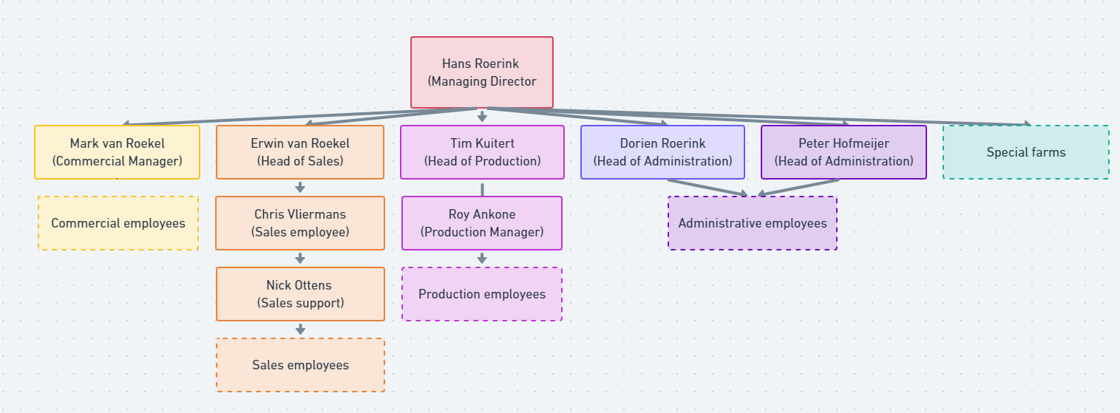Veal Fine is a B2B (family) business with a flat company structure that employs roughly 100 people. They utilise the latest technology to gain control over their supply chain, capacity and reliability with the aim of ensuring the highest quality of meat. Due to being a B2B business, their emphasis lines the sales department. The key element is to maintain customer relationships and profits. Nevertheless, decision-making is done with input of all departments (VealFine, 2021).

Figure . Organogram of Veal Fine. (van Munster, Lucidchart, 2021).

## Internal stakeholders

Internal stakeholders are key to measuring success. This was affirmed by Gary Heerkens, who stated that ‘’one thing that makes internal stakeholders particularly important is that the perceived success of your project is often judged by the perceived satisfaction of internal stakeholders.’’ The internal stakeholders are either directly or financially involved in the operational process and are rewarded for the success of the company (lumen, 2021).

**Employees Veal Fine**

No company can implement strategies without the help of its employees. Therefore, letting employees engage with internal stakeholders is prominent. As said by Rivenburgh (2013), ‘’highly engaged employees always go beyond mere compliance with organizational expectations. They strive to exceed expectations (Stakeholder Map, 2019).’’

The employees are a primary (internal) stakeholder and have time investments, as well as financial investments in the company. They define the production processes of Veal Fine and run the organisation, including company culture (vales) and subsequently employee satisfaction.

**Managers of Veal Fine**

Managers determine the strategy in the organization since they have the final say when it comes to the operational decisions and are financially invested in the company (get a % of profit by meeting sales targets). In addition, managers take on the role of mediator between shareholders, the board of directors and the company itself.

**Owners**

Owners hold a significant share of the company and are (ultimately) responsible for the final impact that a decision may have on the company. Therefore, they are prone to making substantial decisions that concern internal and external stakeholders.

## Customer analysis

‘’A customer is an individual or business that purchases another company’s goods or services.’’ These individuals generate revenues that keep a business going (Kenton, 2021). The customer analysis is a collection of information about the customers. It identifies the target audience, determines their wants and then specifies how the product can and will meet these needs.

The target audience of Veal Fine is service companies, industrial enterprises and retail companies. The customers of the company are in constant demand of quality rosé veal, so accordingly Veal Fine does not pinch-pennies. The largest customer holding is based in Germany (around 80%), with the remaining 20% being distributed among several other European countries, e.g. Spain and the Czech Republic.

### Customer persona and buying process

As just mentioned, Veal Fine’s customers are B2B food-related businesses. A customer persona is a semi-fictional archetype that represents the target audience and is based on data and user research. It gives insight into the wants and needs of prospective customers and reviews potential options (User Testing, 2019).

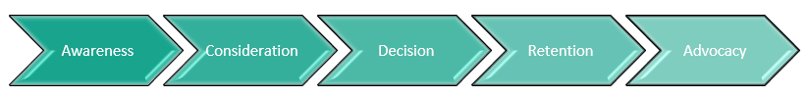To map out the customer journey, a process map is used to define the process that a customer has to go through in order to find their way toward buying rosé veal. It is used to understand the position that a customer has been put in and creates a better understanding that can help deliver a better experience. It aids the purchasing decision and increases qualified sales leads, resulting in improved conversion rates over time (loyal customers, higher-value customers and a better reputation) (Rise Fuel, 2021).

Here, the customer persona and buying process map of Veal Fine can be found: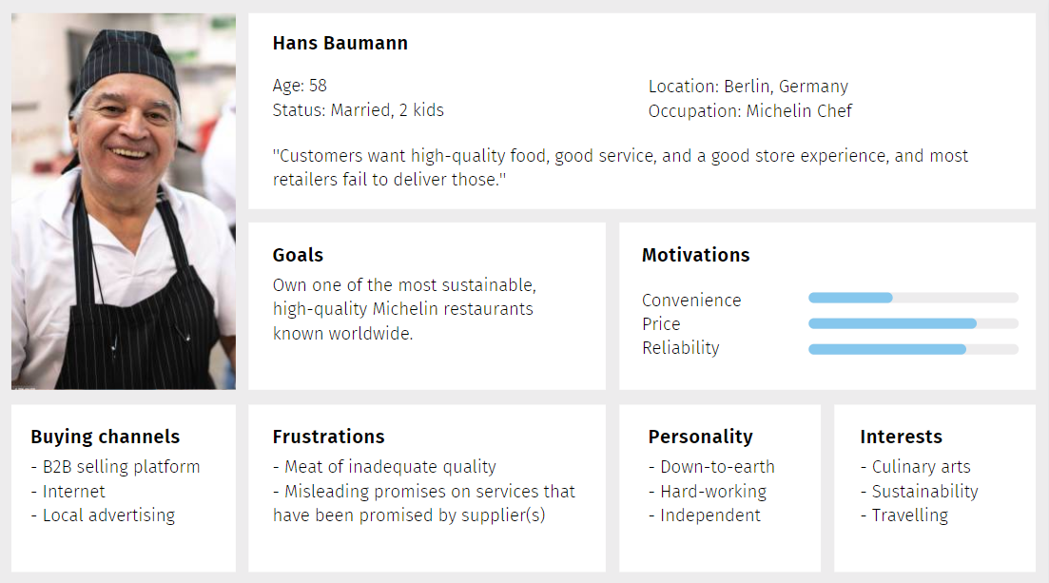

Figure . Customer persona of Veal Fine. (Knopper, Design, 2022).

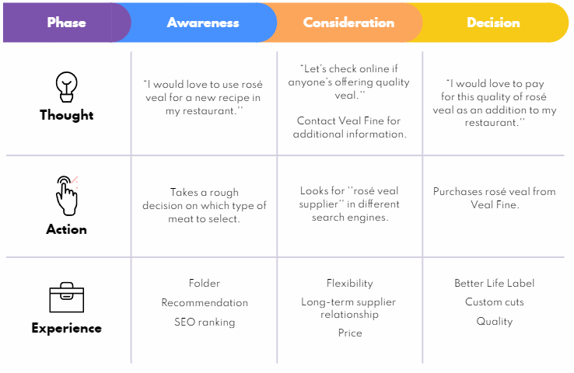

Figure . Buying process map. (Knopper & Younan, Buying process map, 2022).

The purchasing process is a follow-up and formal process of buying goods and services. After the decision-making process, the purchase is made. Before the purchase is made, the buyer and seller have to negotiate on the terms and conditions of the sale to be followed through. Once the agreement is reached, a purchase order is provided and accepted through an (pre set-up) invoice or contract. Hereafter, the transport of goods and delivery terms stated in the sales contract is arranged. After the acceptance of the delivery, the commercial invoice for payment is issued according to the contract (TFIG, 2012).

This process consists of the following elements:

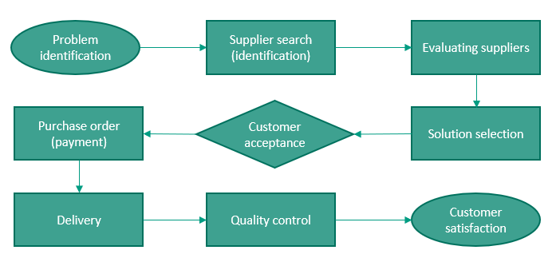

Figure . Purchase Process. (Younan & Knopper, Purchase Process, 2022).

## Market share

Market share is the total percentage of sales in an industry that is acquired by a company in a certain industry. It is calculated by dividing the company’s total sales over a period by the total size of the industry during the same period. By achieving (and increasing) market share, a company can generate revenues faster and gain prestige (Hayes, 2021).

The veal meat industry is a supposedly small part of the overall meat industry, with few competitors. The biggest (two) of these competitors are, VanDrie Group, which has a value of €2.2 billion (: 1.5 million = +- 80 million) (Bedrijvenkring Apeldoorn, 2016) and Danish Crown, with a value of €2.26 billion (: 1.66 million = +- 81 million) (Ridder, 2021). Veal Fine on the other hand is (estimated to be) valued at approximately 80 million. Their value is calculated in comparison to the two largest exporters: the VanDrie Group exports around 1.5 million calves per year and Danish Crown exports about 1.66 million calves per year, while Veal Fine exports nearly 60.000 calves per year. Due to lack of information, only an indication of Veal Fine’s market share can be given (MadeinApeldoorn, 2021).

**Annual turnover**

Veal Fine has a net profit of €100.000.00 and a net margin of €17.719.248, with Germany accounting for 80% of its revenue and the remaining 20% coming from other European countries (, especially Spain and Balkan countries).

## Cost structure

A cost structure is used by a firm to determine prices and find areas in which expenditures can be marked down. The cost structure of Veal Fine is the sum of numerous forms of fixed and variable charges that together frame the total expenses of the company. As a company, Veal Fine has invested the majority of its capital in its products in order to meet the needs of its client(s). It is expected that the firm will incur significant costs during the manufacturing process and product delivery.

Figure . Annual turnover of Veal Fine. (Younan , Annual turnover of Veal Fine, 2022).

Various costs of the company consist of:

|  |  |
| --- | --- |
| Activities (FC and VC) | Costs |
| Calf purchasing | €175 |
| Calf feed | €350 |
| Wages (farmers) | €150 |
| Slaughter | €50 |
| Deboning | €0,40 (per kg) |
| Transport | €0,20 (per kg) |

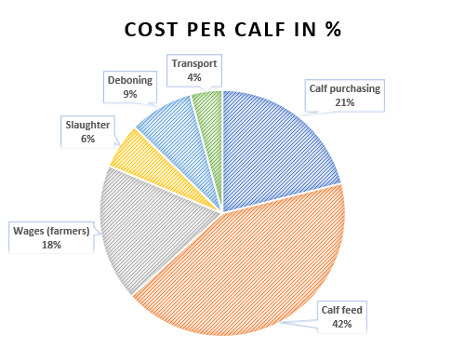On average, a calf amounts to +- 175kg of calf meat. This would come down to spending €830 per calf and €4,75 per kg. The profit that Veal Fine makes is around €0,10 per kg or €17,50 per calf.

The majority of expenses are accounted for by the calf’s nutritional diet. If the calves do not get proper nutrition according to plan, the mat cannot be considered high-quality (or seen as rosé veal). Eventuating that customer satisfaction will decline and market share will be squandered (Roekel M. v., Company Presentation, 2021).

Figure . The cost per calf in %. (Knopper, The Cost per Calf in %, 2022).

## Supply chain

The supply chain is about producing and delivering a product or service. It concerns all aspects of the production process, information communicated, natural / raw materials, human resources and other elements that are related to delivering the end-product (CFI, 2021). Conversely, the generic supply chain starts with raw materials that are then taken to suppliers by logistics. These suppliers act as retailers and sell the products to customers / consumers. This completes the cycle and restarts it.

In case of an e-commerce company, the supply chain looks a little different. It starts with a product order (online) that will then be processed by technology. After this, the payment processors or transactions open up a new supply chain. In between the payment and new supply chain, the product that the customer ordered will be shipped to the customers door by a (third-party) shipping company. In correlation, customer calls or e-mails will be sent to Veal Fine in case of an order (shipment). Next, Veal Fine checks the inventory and notifies the slaughterhouse (meat processing) and deboning station to prepare the order. During this, the office contacts the transport company to prepare the customers shipment. The customers are categorized into 300kg and 600kg groups. Based on this, the costs (of the shipment) will be calculated.

To oversee this whole process, supply chain management is needed. This has to do with planning, designing, manufacturing, keeping track of inventory and distribution phases. If done well, this can help diagnose problems and disruptions quickly and correctly. A way to describe this is the SIPOC model. The SIPOC diagram is a form of process mapping that displays the steps of the supply chain. It can also be called the input-output model. It is used to describe goals and detailed steps on how to achieve this. SIPOC stands for supplier, input, process, process, outputs and customers (Admin, 2017). It translates to the elements in the supply chain, which are, plan, source, make, store, deliver and return. In terms of the company (Veal Fine), the SIPOC looks as follows:

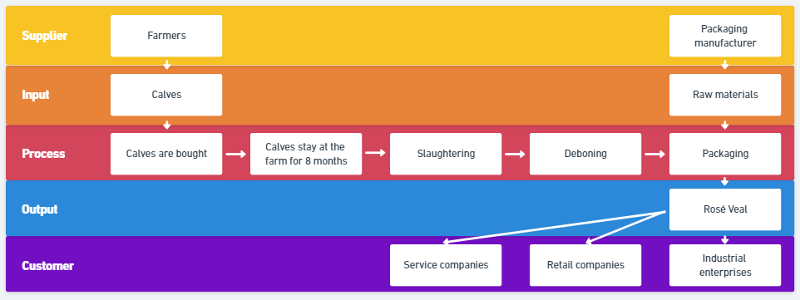

Figure . SIPOC of Veal Fine. (Knopper, Design, 2022).

First, some general information regarding the supply chain will be mentioned: The (male) calves are bought when they are 2 weeks old from 100 different farmers and then stay at the farm for 8 months before they get slaughtered. The female cows on the other hand, are used for milk powder production. The male calves are sold one week after the ‘’slaughtering’’ and have an expiry date of around 45 days between 0 -4 degrees after being processed. Once packaged, the rosé veal is transported by trucks (external partners) to (B2B) customers. About 1100 calves (200T of meat, 175 kg per calf) are processed and shipped each week.

A process map is the visual representation of the inputs, outputs and steps in the process to identify the strengths and weaknesses within the existing processes. It helps reduce cycle times, find defects and enhances productivity (Hessing & PV, 2017):

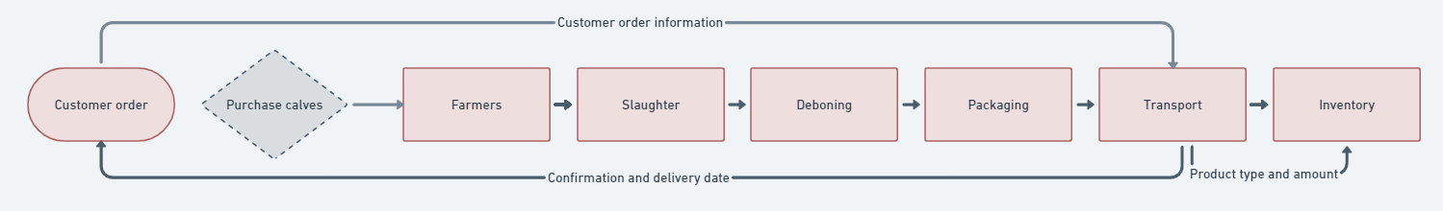

Figure . Simplified process map of Veal Fine. (van Munster, Design, 2022).

# **External analysis**

An external analysis or environmental analysis, defines the process in which organizations examine factors that (in)directly impact their organisation. This is mostly done on a macro scale that includes the industry that the company participates in, the macroeconomy and political, social and demographic elements. The goal is to find opportunities and threats in the industry (segment) that provides profitability and growth (CFI, 2022).

## (Veal) meat consumption market

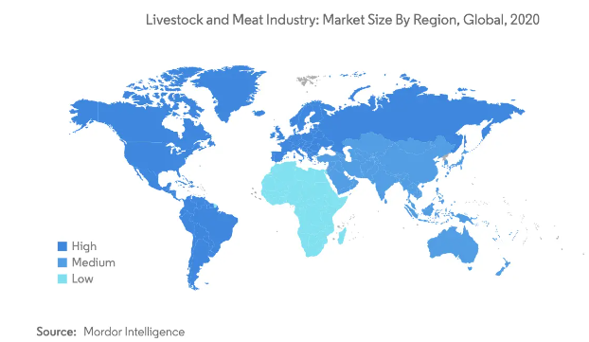The meat market size in 2019 reached $519.51 billion and is expected to reach $862.97 billion by 2027 with a CAGR of 6.24%. It is accumulated that the consumption of packaged foods will increase due to changing lifestyles. Individuals are switching towards ready-to-eat food that is fast and takes little effort to prepare. Therefore, processed meat is expected to see an increase in sales (changing pattern of consumers) (Mordor Intelligence, 2021). On the other hand it is expected that the meat market will stabilise and stay like this for years to come. Nevertheless, Veal Fine can reap benefits as their product(s) has numerous of health benefits (Vealthebook, 2021) that are being promoted by this ‘’new’’ change to a sedentary lifestyle (Statista, 2021).

Figure . Market size of the meat industry, 2020. (Mordor Intelligence, 2021).

There are several constraints that hinder a companies progress when it comes to expanding market share and improving brand image. A common threat for slaughterhouses is animal cruelty, resulting in a bad reputation. The most exerted method is articles that are written about tyrannical slaughter by animal protection pro-lifers (Simon, 2021). However, Veal Fine should be devoid of this as they possess a ‘’Better Life star’’, which indicates that animal welfare is part of the companies key priorities. Additionally, the company is continuously looking for improved animal welfare standards and protocols that govern (can impose or) amend. Not meeting enacted rules set by the government will result in termination (Decerle, 2020).

Figure . Meat consumption in the EU market. (Statista, 2021).

## External stakeholders

The external stakeholders of a company do not work with the company in a direct way, but are still affected by the outcomes of actions made by the business. Alternately, external stakeholders can influence the organisation (indirectly). Beware that several stakeholder interests may be indifferent. To be successful, Veal Fine should align the expectations of stakeholders (Fernando, 2021).

**Competitors**

Market contenders desire fair competition and readiness to cooperate with their competitors. As they are influenced by the decisions that Veal Fine makes, they are indirectly impacted. Oppositely, the decisions that they make can also influence Veal Fine’s decision-making process. Even though they aren’t connected to each other, they can still outperform one another, resulting in market share gain or loss.

**Customers**

Consumers are one of the most important stakeholders any company has. The customers require a good price / performance ratio and service (sometimes even goodwill). They are the driving forces and yield profit. Therefore, the company must track consumer requests and keep up with customer needs and want in order to establish and maintain public relations.

**Government**

In every industry the government wield considerable authority. They make rules and regulations regarding: taxes, jobs, social services, corporate social responsibility (CSR) and donations. This can either aid or constrain a company. In addition, an organization cannot deny the authority of the government. In the case of Veal Fine, there are several legal restrictions and barriers regarding export laws, animal welfare and VAT rates.

**Suppliers**

The company’s suppliers provide with goods and services that they need in order to sell rosé veal. Suppliers require a stable business relationship with good conditions and reliable payment (term adherence). For that reason, it is important to maintain a stable long-term relationship, which has the potential to lead to favourable pricing and partnerships.

## Benchmarking the competitive environment

Benchmarking is used to determine how well a firm performs in comparison to other companies in the same industry in order to identify areas for improvement. To determine and analyse the key behaviours of success, a benchmarking model can be used. This helps a company to identify strengths and weaknesses in their own company, as well as find similarities and differences with businesses in the same industry / sector. It’s of great value when used to compare businesses with each other and find out what differentiates them from one another.

Initially, it is necessary to identify the competitors. In this case, the van Drie Group and Danish Crown are two of the biggest competitors that Veal Fine faces. To stand out from these two big rivals, a benchmark will be made and assessed based on the services and products that these companies offer.

|  |  |  |  |
| --- | --- | --- | --- |
|  | Veal Fine | VanDrie Group | Danish Crown |
| Product pricing  (per kg) | $ (-> $0-$10) | $$ (-> $11-$20) | $ (-> $0 - $10) |
| Product quality | Constant quality throughout the whole supply chain. | Controlled quality by carrying out intensive checks and monitoring calves’ health and quality of their feed. | Animals are raised without antibiotics and the veal (product) reduces waste and maintains yield. |
| Product diversity | Custom made order (on request). | Veal in all sorts of cuts and choice of supplier. | Wide range of standard cuts and special cuts that can be ordered. |
| Customer(s) | Food services and retail industry. | Grocery, calf feed production, retail. | Food services and retail sector. |
| Customer relationship | Visit clients at least once a year and maintain strong ties. | Maintaining long-term customer relationships and making new contacts. | Strong relations with customers all over the world, with the cooperative goal of making most of the profit while being ready to change themselves for sustainable goals. |
| Customer(s) review | 4.4 stars -> professional, neat and friendly personnel. | 2.2 stars -> unhygienic set-up, monopolistic and barbaric ‘’company’’. | 3.4 stars -> no real training for employees, rude full-time employees and poor management. |
| Value proposition | ‘’Excellent quality at all times. By means of this integrated chain we can assure food safety and constant quality.’’ | ‘’Respect for people and animal welfare in a modern, safe and hygienic surrounding.’’ | ‘’Focus on food in all parts of the value chain. Food is what we produce and food is what we sell to customers and consumers across the world.’’ |
| Sustainability | Reducing the CO2 footprint in relation to their veal production throughout the whole supply chain. | Investing in sustainable calf husbandry and exploring alternative raw materials through innovation and investments. | ‘’sustainable future for food’’ -> sustainable alternative, responsible quantities with a clear conscience. |
| Tagline | ‘’The finest in veal.’’ | ‘’A Dutch family-owned business.’’ | ‘’It’s all about food.’’ |

Table . Benchmark Veal Fine and two competitors. (van Roekel, Veal Fine, 2021) (VanDrieGroup, 2022) (Danish Crown, 2022).

### Competitor analysis

A competitor analysis is used to identify businesses with similar products and services in the market. It evaluates these so-called ‘’competitors’’ on several predetermined criteria and determines the unique selling point (differentiation from competitors). It is important to carry out this analysis to stay up to date with market trends and product offerings. This is of essence for both offence and defence strategies (Schooley, 2021).

The term "industry rivalry" refers to the pressure that competitors exert on one another to restrict each other's profit margins. As a result of competition, there is more innovation and companies are more driven to do better than their rivals (CFI, 2022).

Porter’s Five Forces Model or Porter’s Framework describes the five threats that a company can encounter when operating in a market. According to Porter, these threats are: threats of new entries, bargaining power of buyers, bargaining power of suppliers, threats of substitutes and the intensity of competitive rivalry. All five forces revolve around how malleable it is for customers to turn to a competitor. If the meat industry becomes highly competitive, Veal Fine will have to go above and beyond to retain its customer satisfaction and market share (Scott, 2020).

Figure . Porter’s five forces. (smartinsights, 2020).

**Intensity of competition**

The industry has few fierce competitors that try to define themselves through highlighting USPs, attractive product packaging, diverse product folio and by showcasing their items on online platforms (OG Analysis, 2021). When conducting business with a client, the company must strive for customers satisfaction as there are competitors offering similar products. On the assumption that the company loses customers, they could possibly lose their market position.

**Power of customers**

Consumers have the possibility to switch suppliers as there is market competition. The customer has an option to negotiate for lower prices and better deals. On the other hand, it will not be easy to find another supplier with the same quality and service(s). Therefore the company must take the customers wishes into consideration while doing business.

**Potential of new entrants**

As mentioned before, the market is stable and has few competitors. This indicates that Veal Fine can grow its market share without expecting a lot of setbacks. On the other hand there is a lot of potential in the market, thus this can drastically change. That’s why the company should establish their market position and make sure that they have a strong market position.

**Power of suppliers**

When considering the bargaining power of suppliers it becomes clear that Veal Fine does not have a lot of suppliers as they only purchase veal and packaging material. Both of these resources are positioned in quite highly competitive markets (Fortune Business Insights, 2021). This is the reason that Veal Fine can cut down costs and push for other advantages in trade.

**Threat of substitutes**

Veal Fine’s overall product is identical to that of competitors: high-protein, low-fat veal meat. Besides this, there is a threat of plant-based alternatives and other cuts of meat that provide a better nutritional value. This displays that a customer has the option to buy products (or services) at another company. For that reason the company should stick with a USP and strive for (100%) customer satisfaction.

# **SWOT analysis**

The SWOT analysis is used to discover internal (SW) and external (OT) aspects that affect and shape Veal Fine’s current and future operations, as well as to aid in the development of strategic goals. It assists in the identification of strengths (S), weaknesses (W), opportunities (O), and threats (T) in a fact-based study with new perspectives and ideas.

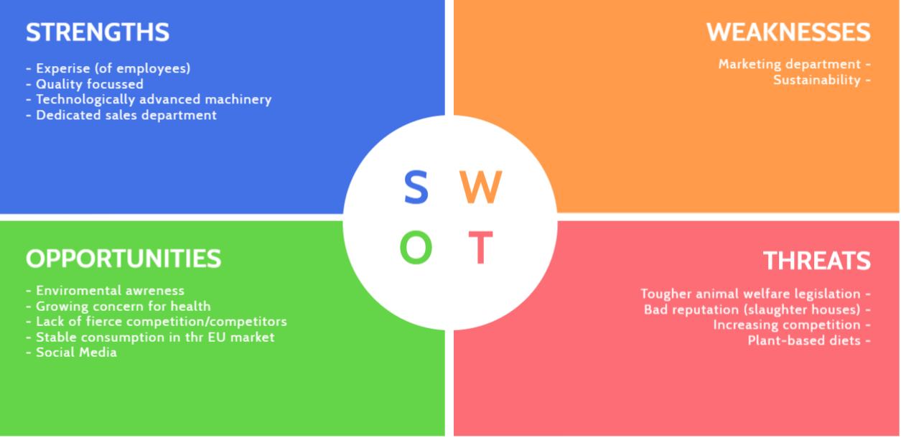

Figure . SWOT of Veal Fine. (Younan, Poster My Wall, 2022).

**Strengths and weaknesses**

**Looking at the internal perspective of the SW(OT) segments, it becomes apparent that the key strengths of Veal Fine are: the expertise of employees, the focus on quality, technologically advanced machinery and dedicated employees, while the weaknesses revolve around: marketing and sustainability.**

***Strengths***

**The core of the company’s organizational processes are its employees: they are the most important asset and face of the company as they manage customer satisfaction by being flexible, versatile and knowledgeable about business procedures. Therefore, the company invests a lot of money into the education (training) of employees. Throughout the organization, high-quality standards are maintained to necessitate audit procedures (rosé veal, service, farming practices and delivery). This increases customer retention and keeps their market share ahead of competitors. Part of their success is due their dedicated sales department, which has effectively introduced Veal Fine to foreign European markets using various strategies with a budget of €400.000 (each year).**

**Moreover, Veal Fine invests in technologically advanced machinery as a means to become more sustainable and efficient. Subsequently, less effort is needed, employee satisfaction increases and manufacturing processes are enhanced.**

***Weaknesses***

Despite the investments in the marketing department to establish brand awareness, only a fraction of the budget has been subsidized for the execution (€10.000). Therefore, more focussed strategies towards B2B business and brand perception have to be carried out. Equivalently, the firm faces challenges when it comes to being (precepted as) a sustainable enterprise. To try and improve, progress has been made regarding sustainable / eco-friendly alternatives and animal welfare.

**Opportunities and threats**

Referring back to the (SW)OT analysis, it becomes clear that the key opportunities of Veal Fine are: a stable meat consumption within the European market and the lack of (numerous) fierce competitors in the veal industry, while the vital threats consist of: animal welfare laws, sustainability and plant-based alternatives.

*Opportunities*

As mentioned before, meat consumption has seen a considerable increase over the past three years (2019-2021), especially in the Asian market. However, the market is stabilising and expected to stay that way for years to come. If this chance is taken, the negotiating power can increase as a result. The opportunity can be accounted for as a virtue of veal’s characteristics (lean high-protein meat) that have been advocated by nutritionists all over the globe (social media).

*Threats*

Environmental awareness is a growing concern, especially in the meat industry since this accounts for 14.5% of the total emission of greenhouse gasses. This issue goes hand in hand with animal welfare and plant-based alternatives as researchers claim that the meat consumption per person is rising and could have negative health consequences, in opposition to plant-based alternatives which provide the same essential nutrients while avoiding animal cruelty.

# **CO2 Calculation - Emissions per sector**

The fundamental cause of global climate change is carbon dioxide emissions. It is commonly acknowledged that the world must cut emissions as soon as possible to avert the worst effects of climate change (Ourworldindata, 2021). For Veal Fine, this means understanding which process sectors produce the most CO2 emission in order to reduce this. The sectors contain elements of the livestock, processing, transportation and utilities segments.

## Carbon dioxide and methane

Carbon dioxide (CO2) is a gas that emits harmful chemicals and is often released by air. It consists of ‘’(one part) carbon and (two parts) oxygen’’. These together create photosynthesis, which is critical when it comes to the survival of life on earth. As more fossil fuels are being used, the CO2 emissions are rising and as a result of this, the earth’s climate changes -> warms up (Airthings, 2021).

In excess of, methane is a natural gas that produces carbon dioxide and water vapor when in contact with oxygen. The main concern is that methane is a greenhouse gas that retains heat. Overall, methane elucidates for at least 25% of all greenhouse gasses. Particular attention has to be paid to methane as it has 25 times the warming power of CO2. On the contrary, CO2 has long-term lasting effects that are held by methane, thus ‘’enlarging’’ the effect (EDF, 2021).

Figure . Equation photosynthesis. (Airthings, 2021).

The natural source of methane (and carbon dioxide) for Veal Fine are the emissions from digestive processes and production that comes forth out of raising cattle and energy generation (UCAR, 2021).

Beef cattle and cows create (2-4%) 6% of all greenhouse gasses produced in the US alone. Each animal produces 220 pounds of methane each year, which is 28 more potent than carbon dioxide when it comes to warming the atmosphere. As meat is becoming increasingly popular in Asian countries, the demand is growing. Therefore, changes have to be made when it comes the emissions that cows produce.

## Footprint in the livestock sector

Livestock farms refer to the usage of domesticated animals that are being reared in agricultural areas to provide products such as: milk, eggs and meat. These production processes lead to the output of carbon dioxide and methane. Farmers who rear animals for meat and milk account for 65% of the overall 14,5% of the total GHG emissions produced by the livestock sector worldwide (FAO, 2022). Accordingly, a growing number of farmers and organizations are trying to pursue a more eco-friendly and responsible way to raise and breed their livestock. This is partially influenced by the government and other external influenced.

Currently, Veal Fine possesses around 5-6 farmsteads. Each farm computes around 200 calves on a weekly basis, totalling around 1100. Once the calves are eight months old, they will be butchered, deboned, packaged and sent to the customer (van Roekel, VealFine presentation interview , 2021).

Veal Fine’s CO2 (and CH4) emission is calculated based on the livestock sector and incorporates:

* Enteric fermentation: methane that is produced during the digestive processes of animals (calves). This can be described as the decomposition and fermentation of fibres, starches and sugars in the tract or rumen (FAO, 2022).
* Manure management: is often seen as the ‘’capturing, handling, storing, treating and utilization of manures (USDA, 2020) to produce fuels for heating, transportation and energy generation (EPA, 2021).’’
* Manufacture of forage: the use of crops for grazing livestock (feed). It covers the inadequacy between demand and supply (Penn State Extension, 2022).

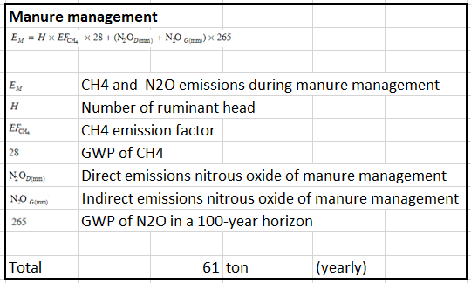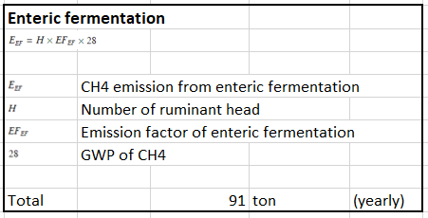

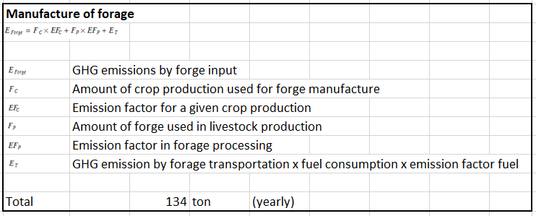

Figure . GHG emissions from farm management, Veal Fine, 2021. (Knopper, GHG Emissions of the Livestock Sector at Veal Fine, 2022),

Sources used for calculation: (Brander, 2012), (Dong, et al., Emissions from livestock and manure management, 2006), (Dong, et al., Emissions from livestock and manure management, 2020), (Gibbs, Johnson, Lasse, & Ulyatt, 2003), (Kuikman, van der Hoek, Smit, & Zwart, 2007), (Muthu, 2015), (Nevison & Kaiser, 2003) and(University of Adelaide , 2019) (Brander, 2012).

It should be noted that the calculations conducted, use the average emission factors per given category, therefore it is an estimated indication of the emissions that Veal Fine produces in their livestock sector. As shown, the manufacture of forage is the biggest emitter of CO2. In comparison this section produces 1.5x the enteric fermentation and twice as much as manure management. Consequently it is one of the company’s largest CO2 emitters that emit 286 tons (per year). Therefore, this should be the main concern when it comes to reducing the carbon footprint.

## Footprint in the transportation sector

Transport accounts for 24% of the total carbon dioxide emission worldwide. Of this, 29.4% comes forth out of trucks carrying freight. It is expected that global transport and car ownership rates rise by 60%. Combined, passenger and freight pressure result in a large increase in (transport) emissions. On top of this is has been researched and proven by Steven Davis and his colleagues that eliminating long-distance road freight is difficult to eliminate (Ritchie, Cars, planes, trains: where do CO2 emissions from transport come from?, 2020).

Pollution from vehicles and transport modes have a negative impact on natural (re)sources such as air, water and soil. On top of this, pollutants such as nitrous oxide, deplete the ozone layer, which is necessary for protection against UV rays (Reynolds Mason , 2021).

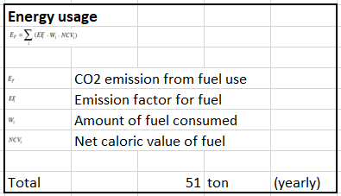**Veal Fine uses (diesel) trucks for the transportation of their goods (rosé veal) to customers. Their customers are located in different countries and therefore a route is set up that will be driven once a week (with 250 pallets in total). The starting point is their headquarters in Enschede, The Netherlands. The route locations include: Amsterdam, Berlin, Cologne, Lisbon, Madrid, Paris, Copenhagen, Stockholm, Prague and Budapest**.

Figure . GHG emissions from transport, Veal Fine, 2021. (GHG emissions from transport, 2022) (Marquard & Bahls, 2021) (Zijlema, 2020).

The calculation of CO2 in relation to the fuel usage of Veal Fine’s transport is based on given factors and thus give a general overview of the output. As the company uses diesel trucks, many harmful emissions, such as ground-level ozone are released during usage (EIA, 2021). Despite the fact that this segment (altogether) produces the least amount of CO2 during the production process, it should not be neglected. In comparison to other transportation modes, such as railway, diesel is remarkably worse, but seemingly efficient (Adlam Transport, 2022).

## Impact of utilities

The utilities refer to the category Veal Fine’s essential facilities utilised to run the business. These consist of electricity, natural gas and water. Using these facilities all leads to a substantial quantity of CO2.

The meat industry is characterised by the high demand for electricity and water due to the consummation of energy by chilling systems and adaptation to industrial needs for ready-to-adopt technologies. The development of meat chilling techniques is moving towards slow methods and shock methods. However, either of these may lead to deteriorated quality of meat which is called *cold shortening*. To prevent this (*rigor mortis state*) several biophysical methods are carried out during the pre-chilling period. This includes: tender stretching, electrostimulation or delayed conditioning. The meat processing plants require both low-voltage (*ESNN*, up to 100V) and high-voltage (*HVES*, from 100 to 300V) (Banach, Zywica, Matusevicius, & Annamalai, 2021).

While the world's population approaches 10 billion people, environmental scientists estimate freshwater shortages to be one of the most significant environmental challenges in the next 50 years (Small business Ideas, 2021). Instead of using water once, the company has to preserve water by re-using it.

The company’s provider of water is Vitens. This company cleanses and supplies drinking water that is dependable, economical, and sustainable. This is the exact reason that Veal Fine chose this firm: water purification and non-invasive extraction from natural resources. Before final consumption, each animal requires roughly 7000 litres of water to raise, clean and debone. Therefore it is one of the most water-intensive industries (Vitens, 2022). On a monthly basis, Veal Fine uses about 3.804m3 of water, resulting in a total of 45.648 m3 water (usage) per year (Delynko, 2019). This is a lot when compared to other industries, but relatively good when compared to other livestock companies (Waterfootprint, 2020).

Among fossil fuels, natural gas has a better reputation. When compared to oil or coal, this fossil fuel generates fewer greenhouse emissions when burned. However, it cannot be said that it is environmentally beneficial. Natural gas emits 50 to 60% less CO2 emissions in the air than when it’s burned in power plants with standard oil or coal. In addition, it emits greenhouse gasses with a shorter life cycle into the atmosphere. Therefore, Veal Fine uses only natural gas to generate energy for their farm management operation to less damage the environment however, this is not enough. Although it deals less damage, there are several available alternatives that produce less CO2 to generate energy (MET Group, 2021).

Veal Fine's energy (gas) provider is Pure Energy, based in Enschede, The Netherlands. The company is regarded as the most environmentally friendly energy supplier in the country, relying only on less invasive means to generate energy, such as natural gas.

Figure . Non-renewable energy, C02 usage per kg. (MET Group, 2021).

Veal Fine uses 1778 m3 on a monthly basis, which accumulates to 21336 m3 of gas per year. Compared to other (similar) companies, this is not significantly high (Roekel M. v., Company Presentation, 2021). However, no matter how small the (usage) amount is, it may contribute to a more sustainable future if it is derived from renewable energy (Pure-energie, 2022).

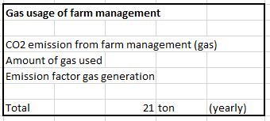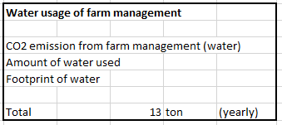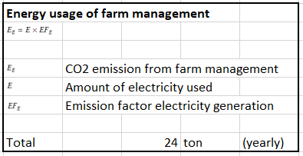

Figure . GHG emissions from utilities in farm management. (Davey, 2007) (Willms, 2008).

The utilities of Veal Fine are the second largest contributor to their CO2 emissions, especially electricity (energy) usage. As a result, the company must devote a considerable amount of its resources to the utilities (and livestock) sector as these are the biggest concerns. To improve this, several innovative technologies that have been produced over the last decade can be used to substantially lower CO2 emission.

* (Note: the complete overview of calculations and explanations can be found in Appendix I)

# **Conclusion**

The company’s current mission and vision revolve around satisfying customers by ‘’offering consistent quality, flexibility and reliability.’’ This all leads to their aim of becoming more sustainable and environmentally friendly with the help of their strategic goals that focus on adaptability and innovation. The company structure revolves around a flat organisation structure with few levels of management. This leads to the key of measuring success with internal stakeholders that are directly or financially involved. The best measure of accomplishment is judged by customers as this group generates the revenue that keeps Veal Fine moving. The company supplies service companies, industrial enterprises and retail companies located in Europe (specifically Germany, 80%).

The current market share of the company is estimated to be €80 million with a net margin of +- €17.7 million (yearly). This is on account of the cost structure that focusses on investing capital into products (peculiarly nutrition for livestock) to meet customer needs. The supply chain of the company is involved in this as the production costs are enraptured in the SIPOC model. This is compromised of the supplier, input, process, output and customer. To oversee this whole process, supply chain management is used to translate and describe the goals and detailed steps of the SIPOC.

The external environment of the company defines the influence on the company in the macroenvironment. Overall, the meat industry is expected to reach $862.97 billion by 2027 with a CAGR of 6.24%. The extrinsic groups that influence this are external stakeholders. These categories may have conflicting interests in comparison to Veal Fine and can have a positive or negative impact.

To determine the performance of the company, an impartial benchmark is set up to compare Veal Fine to its two biggest competitors (VanDrie Group and Danish Crown). The result is that Veal Fine is doing relatively well as the company is considered more prestigious (customer satisfaction) and cost-effective. This induces the competitor analysis and market intensity. On the whole, the company participates in a fairly competitive environment with few competitors in its market segment.

The SWOT closes this in by rephrasing the strengths, weaknesses, opportunities and threats that the company faces in correlation to its strategic goals. In a general sense, this consists of (SW) technological development and expertise in opposition to department focus (marketing) and sustainability. In addition, the company operates in a market with a lack of (numerous) fierce competitors in its segment, but should be aware of the growing environmental concern.

Following up on this, the greenhouse gas emissions are calculated to create an overview on which aspects (segments) the company should focus on to reduce their emissions and avert worse effects. The main focus is put on the livestock, transportation and utilities as these are most common and important during production processes. The livestock sector accounts for 14.5% of the total GHG emission produced by the livestock sector and generates the most GHG emissions for Veal Fine when it comes to manufacture of forage and enteric fermentation. On the other hand, the (outsourced) transportation accounts for a small minority of the total output. Regardless, it should be considered as there are relevant alternative transportation modes. Moreover, the utilities are the second biggest source of emissions for the industry and Veal Fine. They account for the depletion of resources and can certainly be improved with the use of innovative technologies.

To conclude, Veal Fine is a flat organisation structure with a mission and vision that support its sustainable goals. Their performance is measured by internal and external stakeholders and supported with the use of their strengths, weaknesses, opportunities and threats. To reach their goal(s) calculations on the(ir) greenhouse gas emissions have been carried out as a fundamental for further recommendations and implementations (impact).

# **Sustainable alternatives for Veal Fine**

There has been a long-standing issue regarding the environment vs. the profit of a company. In this day and age there are new ways in which companies can utilize and build innovative flexible methods to produce their products. Various areas / departments in the industry that companies such as Veal Fine can apply to become more sustainable and reduce their carbon footprint. By applying new sustainable methods that can be used in this sector, firms can drastically reduce their footprint and help regenerate the planet (Oliver, 2021). Therefore, the upcoming years will shape the organization’s abilities to reform their ways of producing and doing business to preserve the world for the next generation(s) to come.

To pursue a reduction in emissions, changed in farm management need to be realised. Practical tools that can be used for the implementation of sustainable rosé veal production include measures that are aimed at the improvement of animal productivity, feed quality, soil fertility, transport and the use of renewable energy sources.

## Livestock sector

Reducing the footprint of the livestock sector has been a long-standing issue that must be addressed in order to prevent further global warming. The estimated growth of meat consumption is expected to align with the population increase, thus solutions and alternatives in the livestock sector must be found to decrease the emission output (FAO, 2014).

There are several applications that can be implemented to reduce the methane and CO2 output of the livestock sector. The most feasible option for the company would be to adjust calves diet by adding supplements in order to slow down methane production and reduce food waste or to carry out a new form of breeding (eco-friendly) calves.

**Automatic farming technologies**

To make livestock manufacturing processes more efficient and automated, BECCS (Bioenergy with Carbon Capture and Storage should be executed as a means of extracting bioenergy from biomass and (capturing) storing carbon. As a result, carbon will be removed from the atmosphere.

Another suggestion would be to implement a smart barn. A prototype should be executed in combination with the BECCS (Bioenergy with Carbon Capture and Storage) technology (IEA, 2021). The smart barn itself is integrated with technology that improves the life of livestock and gives the company ‘’performance’’ results. The most applicable elements of smart barns are:

* Automated feeding
* Climate control
* Eco-Floors
* Filter floor(s) to prevent (“drijfmest”) floating manure and separate urine from manure

(Balemans, 2021)

**Food waste and seaweed diet**

A potent way to (indirectly) reduce CO2 emissions is to include recycled food waste from crop residue and agro-industrial products into calf feed. This so-called ‘’food waste’’ can be fed to most livestock and is a cheaper alternative to current diets. In addition, the ‘’leftover food’’ can be combined with the veal’s diet to be more nutritional. Therefore it is an easy yet efficient method to cut down on costs and CO2 emissions (FAO, 2019).

Adding supplements to a calves diet has the potential to reduce methane output (manure management). For instance, scientific research has shown that adding 0.2% of seaweed, particularly the red tropical species (Asparagopis) as it is high in bromoform, leads to a 98% output reduction if used for at least 3 months. If a more common species of seaweed (1%) would be used, a methane emission reduction of 60% could be obtained (Quinton, Cows and climate change, 2019). On top of this seaweed increases the thyroid, which helps with growth, lowers blood pressure, promotes health, increases digestibility, supports blood sugar management and supports the immune system by fighting against bacteria (Lewin, 2021). Generally, more research has to be carried out in regard to seaweed, but the results seem promising (Slater, 2021). The Swedish start-up, Volta Greentech, has started producing this feed supplement in combination with enzymes to reduce the action of microbial *methanogens*. This method is also used to optimise temperature, nutrients and light (Volta Greentech, 2022)As veal require a special diet, this recommendation has been made on the basis that the seaweed would only replace 0.2 – 3% of the overall diet.

Figure . Recycled food process. (FAO, 2019).

It must be noted that other plant-based feed additives and supplements are proven to be efficient. These diets are mainly made up out of soy-based consumables, however this heavily clashes against the consumer rate of plant-based foods for humans. On top of this, a lot of deforestation would be required for soy-based products. That is why synthetic chemicals (*tannis*), adding more corn or increasing the fats and oils intake of the calves would also be a great alternative. In addition, pasture-based diets could be an effective option for reducing CO2. This recommendation was made by L. Whistance from the organisation’s. Soil Association and SRUC concluded that offering animals a diverse landscape with trees and herb-rich pastures in managed grazing systems will manage the intake of digestible matter and pasture regrowth (L, 2018).

## Transportation

The transport sector has numerous options when it comes to reducing the CO2 output. As of now, diesel trucks are used to transport goods while diesel by itself is one of the main polluters to this earth. Most alternatives mentioned regard accessible options to Veal Fine and contain the differentiation of two transportation modes.

The total distance of the route that is driven on a weekly basis to deliver rosé veal to customers is roughly 960km. This will be used as an indication for alternative recommendations.

**Hybrid electric trucks**

One of the solutions could be a hybrid truck. These trucks have an internal combustion engine that is combined with an electric motor and an onboard generator that generates power, which is managed by software and sent to a battery pack. The combination that we suggest is a hybrid that consists of electrical power and diesel (Forbes, 2021). This is because diesel trucks overall perform better than gasoline (benzine) trucks. This is due to the fact that diesel self-ignites, works a more consistent temperature and offer traction (Auffenberg, 2022). The disadvantage is that each truck will have to be recharged after 600-900km (electric) (Ziemkowska, 2019), however the total route distance is around 900-1000km hence why this would be a great option.

**Intermodal freight**

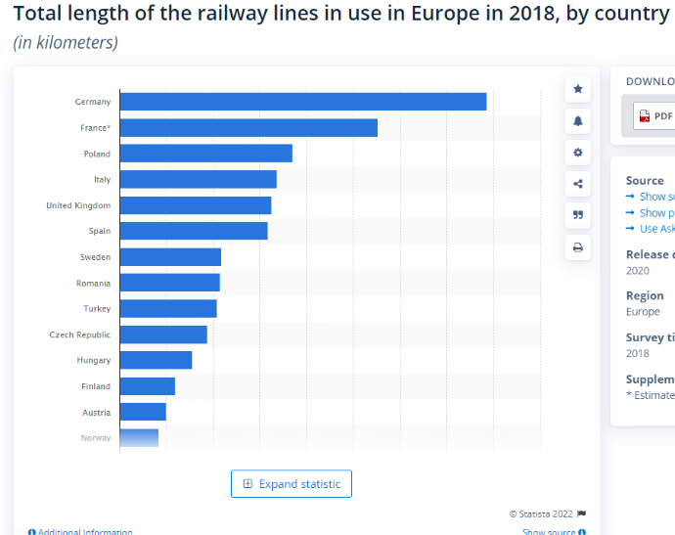Intermodal is the combination of rail transport and truck freight. Rail transport is one of the most eco-friendly, low exhaust, transportation modes. It is used to travel long distances, is high speed, reliable and punctual (Larsen, 2018). Recently, European rail freight companies have created a coalition with the aim of increasing rail freight from 18% to 30% (by 2030), creating €100 billion economic gain and reducing the CO2 emissions by 290 million tons (Rail Freight Forward, 2021). One third of freight travels less than 1000km as it costs far less energy than a truck (Webber, 2019). The reason for merging this with truck transport is that it will reduce the overall distance that the truck covers and deliver the product to the consumer in a convenient and conscious way.

Figure . Total length of railway lines, 2018. (Statista Research Department, 2020)

## Utilities

The production of rosé veal makes intensive use of utilities to convert raw materials into edible, high-value food products. Due to higher (legal) requirements, it is observed that the usage and prices have increased significantly. The consumption of utilities in this industry is affected by several factors dependant on the facility size, processing technologies and production capacity (Li, Ziara, Dvorak, & Subbiah, 2022).

Several improvements can be made when it comes to these utilities. As seen in the (earlier) calculations, the energy usage of Veal Fine is one of the main concerns when it comes to the CO2 output and should therefore be a focal point. For the gas and water usage makeshifts can make a huge difference on the consumption and should for that reason be considered.

**Electricity**

Feedlots often rely on manual operations and direct-on-line (DOL) starters. This leads to large load spikes and delays, which could be diminished by automation and motor type options such as star, delta or star-delta starters. Manual labour and reliance cost the implementation of energy practices while spikes in kVA cause full load and full line voltage to be applied to motor terminals at the same time (MLA, 2019). In combination with this variable speed drives (VSD) can reduce operating costs by up to 50% and lower energy consumption. This is due evaporative function that runs at the same speed after achieving optimal temperatures (Grainger, 2021).

Another important measure is to control the heating and cooling system as it is one of the biggest contributors to the electricity bill on a monthly basis. There are several ways to do this, such as: minimising the cool load, minimising the temperature lift, accounting for variable operation conditions, selecting the most efficient refrigeration cycle and components and / or designing an effective control system (UN Environment, 2018).

* (Note: all heating and cooling system methods mentioned will be elaborated on and explained in detail in Appendix II).

**Gas**

The mitigation measures can be used to reduce overall gas usage and focus on efficiency improvements regarding on-farm usage and biosystems with the use of technological intervention. The most valuable option would be transfer and knowledge exchange through a carbon navigator. This is a tool that provides farmers with valuable information such as emissions and environmental gains in terms of:

* Husbandry (animal breeding, feed supplements and improved pastures)
* Management systems (stocking rates and biological control)
* Manure management: high-protein forage with high-energy supplements for manure stockpiles with aeration and access to composting (Government of Western Australia, 2021).

**Water**

To develop a recommendation, there has to be an understanding of how water is currently being used in the production process. The balance includes the following areas: process operations, utilities, leaks, sanitary use, waste streams, laundry and irrigation. To minimise water usage, the focus will be on processes and facilities.

The recycling of water for a particular operation or process can be done with the use of (scheduled) spray coolers, counter-flow designs or a cooling tower. Each of these narrates the use of water re-use separately from its original use. Contrarily the process control is in correlation with improving the use of water. For example, nozzles and swivel assemblies often lead to waste water as the orifices wear out over time and allow gallons of water to be wasted per minute. Therefore, strict maintenance should be placed on these nozzles. This can be done by checking monthly or replacing them every six months to one year, depending on if it’s a single or double shift plant (Ogren, 2018).

In addition, monitoring the water consumption with an accurate back-up measurement can be a good investment when it comes to municipal sewage bills. One of the best options would be to implement a water tracking meter since this helps identify problem areas quickly, reduces facility downtown, notifies equipment repair and warns for product loss (Bowser, 2016).

* (Note that all the invoices of Veal Fine with regard to their utilities can be found in Appendix

III)

# **Implementation**

The implementation is described as the act of putting something into action and making it successful in a way that ignores the old in favour of the new in this instant. Putting the recommendation of Veal Fine’s CO2 reduction as a priority when developing the impact on a company and its management structure is crucial when it comes to managing the capabilities. It estimates the side effects and opposition of major changes in connection to the implementation. Changes that occur require adjustments with the use of exchange of views. Once discussed and agreed upon, a plan with its consequences is required (Merriam, 2021).

## Management and organisation

Veal Fine is a question mark (BCG-matrix) company with a flat organisational structure. This means that the company doesn’t have a particularly high market share, but the growth potential is high. The organisational structure displays that there are few levels of management in the workforce. Therefore, there is a ‘’balanced authority’’ and input from different departments. The impact could take different approaches per segment and can be influenced by different levels of the organisation.

In general, the company is not willing to expand its customer acquiree. At present they have a production facility with high quality materials and prompt employees. The company has several farms under management and has applied solar panels to 50% of these farms.

The recommendation focusses on separating the recommendations into variable elements that can be applied to each employee segment: farmers, office, field-workers, etc. This is due the fact that each department has a different perspective on the impact that a recommendation may have. This will lead to an overall overview of the pros and cons of each solution per field and the most advantageous outcome. The advice opposes the outsourcing of information considering this is confidential. Therefore, the company should manage this with the head of each department and hire additional employees if needed (due to workload).

The organisational change could change as a consequence of new policies and approaches to the reduction of greenhouse gas emissions. A reason could be the conversion of resources or the pursuit of new innovations. By constructing better communication lines throughout the company, it could solve internal problems and cut down on expenses (return on investment).

As a result of the implemented recommendations, the company (Veal Fine) has to optimise its production processes and unify its team. The decision-making should be done from the top down and each level of management should be given accountability and responsibility. Thus, transparent communication is required for effective change management. This includes constant feedback from other management levels and adaptation to a solid transition plan. In addition, there should be employee training and development with regards to knowledge and expertise of the implemented recommendations. For more insight into the recommendations and adaptations, several companies specialised in the field can be contacted (an example is Volta Greentech: feed innovations)

Overall, three aspects should be considered when assessing the need for change: the scope of change, the level of change and the intention of change. It is very important that the company selects the option that suits them best in terms of all (four) departments and long term-strategy.

## Marketing and sales

The marketing implementation plan consists of internal and external aspects. The plan combines internal changes and external awareness based on the (impact of) CO2 emissions. The marketing budget consists of €10.000 and the sales budget of €400.000. Therefore, the focus will be put on a combination of marketing and sales

The internal marketing plan: before the reduction in the output of greenhouse gas emissions can be reduced, intel is needed on the current output and sources that generate the biggest emissions. The internal marketing is all about creating a positive culture within the company and is important for employee retention. It is important to note down the internal requirements regarding resources that can be utilised to reduce greenhouse gas emissions: resources include, raw materials, budget, manpower, knowledge (expertise), etc. After an internal overview with regard to management, finance and planning has been made, a roadmap has to be designed. This concerns the necessary changes that need to be made to optimise the results and incorporate a contingency plan. During and after this process, the results should be measured and reviewed to understand how effort influences the overall goal. Once this is done, the final results should be communicated to the other departments (management, finance, etc.).

Consecutively, the external analysis comes into play. It aims at one goal, which is to connect (Veal Fine’s) values, products and services to its customers (and consumers). In this case it covers three main points: information dissemination, image (building and) management and brand reach.

1. Information dissemination: the sharing of information to (current) external stakeholders (customers, suppliers, etc.) through online communications such as LinkedIn and e-mail.
2. Image management: the perspective that customers and stakeholders perceive impacts brand image. By addressing greenhouse gasses the customers’ concern is addressed and constructs a positive image of the target audience.
3. Brand’s reach: even though the (Veal Fine’s) focus isn’t on brand expansion, it serves to encourage potential customers to try products and services. Promoting the consumption of veal can result in an increasing demand of rosé veal suppliers whereas encouraging partnerships and collaboration with other brands leads to continued interest of (current) customers.

Overall, the marketing is used to pose opportunities for conscious and sustainable marketing. With the use of internal and external marketing methods mentioned above, new technologies and their benefits can be communicated to all stakeholders. As a whole, this will suggest an ethical image of the company in public consciousness.

## Finance

The cost implementation sums up all of the actual costs that are generated trying to implement the measures suggested. The applicable expenses should be capitalised and arranged via a balance sheet with software (management) support. Comprehensively, the organisations accessible software that is used for internal use is substantiated with external influences such as hosting arrangements and capitalised terms of arrangement (Ilgenstein, Avila, & Federle, 2020).

Here, the focus is on the ‘’additional costs’’ that the recommendations mentioned before would bring along. The mentioned costs are indicatory and are not set in stone!

As mentioned before, the livestock recommendations focus on: automatic farming technologies (BECCS), smart barns and nutritional diets. The following costs are produced when implementing these adjustments:

* Bioenergy with carbon capture and storage: the average cost of a BECCS system varies from $15-400 per tonne of CO2 that has been avoided, depending on the sector. Consideration for this change is of importance as it is expected to be the most widely used CDR technology from 2030 until 2100. This is due the fact that it enables negative emissions and replaces the offset of fossil-fuel derives sources with bioenergy (Global CCS Institute, 2019).

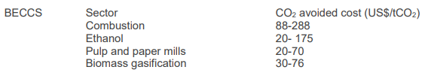

Figure . Cost of CCS applied to different sectors. (Global CCS Institute, 2019).

* Smart barns: this system can monitor several things at once (+20) and needs an investment of +- €2500 (or +-€35 per month). In comparison to hard-wired systems, this is a fraction of the price and gives a more thorough overview of all production processes (OCJ, 2014).
* Nutritional diets: altogether a combination of low-grain, high-forest nourishment can lead to the reduction of costs up to €35.320 - €76.490 for a herd of up to 1000 calves. Overall, the total gains differentiate from €0,16 (low) to 0,32 (high) per kg (Roque , et al., 2021).

The average costs on transportation alternatives are variables as this is outsourced to a third-party. The transportation costs are for the customer and are seen as excluded (Ex. Works.).Due this, the company or customer will not have to buy the trucks, but instead pay a (€) amount per route or delivery. The most suitable transportation options would be hybrid electric trucks and intermodal freight. A transportation cost indication list has been set up as follows:

|  |  |  |  |
| --- | --- | --- | --- |
| **Transport mode** | **Cost** | **Distance (average)** | **Time (average) in hours** |
| Airfreight | €4-8 (per km) | 9575 km | 16 |
| Train | €0,60 - €0,70 (per kg) | 9575 km | ! in progress ! |
| Truck | €1,60 (per km) | 9575 km | 96 |

Figure . Transportation costs. (Freightos, 2022) (Gronkvist, 2018) (Mehnken, 2021).

Withal, the utilities used for the manufacturing process can be considerably improved. The recommendations provided are based on the reckoning of each segment and are developed based on preference and significance. The suggestions are meant to increase efficiency and generate autonomous processes. Consecutively, this implementation can bring along the following costs:

* Direct-on-line (DOL) with variable speed drives (VSD): the price of a DOL and VSD varies from €150 to €400 depending on the usage (power) requirements (Farnell, 2022) (VFDS, 2022). The combination of these two starters can lead to a 50% reduction in power that is required for the drive control of multiple motors (Bacidore, 2017).
* Carbon navigator: this tool is used to quantify environmental gains by looking at (individual) changes per farm. It illustrates GHG emissions and increased profitability that comes along with change. The so called ‘’carbon navigator’’ is set up by an approved advisor or trained company employee on the basis of several criteria that outline the selection of technologies and practices. The costs depend on the outsourcing of the suggestion (Grange, 2016).
* Nozzles and swivel with a water tracking meter: the nozzle and swivel are relevantly cheap (+- €20) and if maintained well account for barely any costs (Amazon, 2022). The water tracking meters on the other hand cost around €275 each and are used to increase water conservation, fix irrigation problems and reduce consumption up to 70% (Goldenstein, 2015).

Our recommendation would focus on the recommendations within the livestock (nutritional diets) and utility sector (electricity and water) as these are cost-effective and produce operating profit in the long-run. Something that should be kept in mind is the purchase costs as this is a moderate investment that could lead to relative profitability.

## Planning

Prior to the practical execution a planning is necessary as to decide on future plans. It concerns what, how, when and who should do it with regards to setting goals and arranging them into logical order. A plan is the ace of growing and maintaining an existing business and allocates resources to prepare the company for uncertainty even during ambiguous circumstances (Chron, 2020).

Due to shifting global viewpoints, firms are realising the importance and need of sustainability as it is becoming increasingly important to bridge knowledge-to-action gap by implementing sustainable strategies. The research purpose (of Veal Fine) is to acknowledge and create an understanding of what it means to be environmentally neutral. In addition, sustainable methods improve brand image and reduce expenses if known how to be utilised in an organisation.

As there is a lack of understanding, the research has been outsourced. The ‘’third-party’’ will recommend the most viable options based on research and calculations. The first step is to find a company that has expert knowledge in the field of CO2 reduction for meat producers. By calculating and analysing the greenhouse gas emissions of each process involved in the production, recommendations on ecologically sound alternatives.

Ensuring the calculation and analysis of sustainable alternative approaches results in several recommendations that can be chosen based on: budget, planning, marketing (and sales) and M&O. The decision-making demands on the potential that each solution can bring to the company.

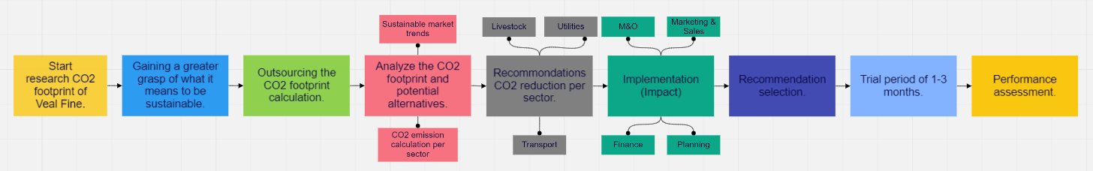After selection, assessment and implementation of the possible solution will be put to the test in a 1 to 3 months trial. In conclusion, the technique enforced can either be changed, tweaked or put in (permanent) place.

Figure . Planning implementation visual. (Younan, Workspace, 2022).

For a clearer overview of the planning, check out this link: <https://miro.com/welcomeonboard/VmM0WUFpM1dVdWJWYnVLdTdaWGZjOGgybjV0YzBXOEY2UDN1TEtmTFl3Sk1oWTNId0JjYlBYWng2ZTd3bTB6MXwzNDU4NzY0NTE1NzU4OTE5NzE1?invite_link_id=508067900977>

# **Group reflection**

The group formed based on the availability of classmates. Therefore, the team was composed based on election. As group, we started as 7 members and are now left with 6. During the kick-off week, we decipher the responsibilities of each group member -> Chantal is the monitor, Jan is the leader, Nadia is a shaper, Romario is a specialist, Rowan is a shaper and Trang is a plant.

To ensure appropriate teamwork, a cooperation agreement was constructed during the first Teams meeting that we held as a group. Here, we brainstormed about rules and wrote them down. If someone did not agree, we would argue as to why or why not it should be implemented and voted. On condition that a rule did not gain the majority of votes, it would be disbanded.

Looking back at the overall group performance (over the previous six months), it becomes evident that the first few weeks went relatively well: all group members were present, everyone handed in their individual work on time and was approachable through communication tools such as, WhatsApp, Teams and e-mail. For instance, while working on the theoretical framework, members could ask each other for help and each individual was willing to put in the extra effort. However, after the first few weeks, it became clear that there was a lack of communication holding us back from further development. The main reason for this is that our group size felt ‘’hard to manage’’ and brings difficulty when it comes to comparing individual schedules and perspectives. An example of this is that two team members made the same assignments even though everything had been divided. During meetings it was lousy as everyone was talking over one another. There was no structure or rules when it came to when to speak and when to listen. Subsequently, this leads to irritation and friction between certain members. This could have been avoided if others had intervened more and stricter rules were recorded. Despite that, deadlines and other important information should not only be sent on WhatsApp, but also e-mail.

Henceforward, deadlines were not met on time or were not of quality. As mentioned before, this was due to a lack of communication. An example of this is that some members did not attend meetings and therefore ‘’forgot’’ about the deadline. The members who were present divided the tasks and meet regular deadlines. Therefore, it would have been nice if all team members attended meetings as to avoid confusion. For future improvements, such behaviour should be referred to the cooperation agreement and lead to a strike.

The most important lesson acquired during the group work is communication and the importance of it. Without it, a lot of things can go wrong, such as putting in extra work, growing irritation and ineffectiveness of tasks.

Looking back at the group work, there is one main improvement that has to be made: communication is key. This provides a good working atmosphere, ensures cooperation and effectiveness. For us, communication worsened every week and more difficulty arose. Communication has to be done on several platforms to ensure that it is being read and not overridden by other messages. The attributes that came with miscommunication were unawareness of deadlines and elements that had to be included in each part. Referring to the cooperation agreement and informing people about the consequences is something that should have been used more effectively as it is a rightful thing to follow the rules of the cooperation agreement.

## Individual group reflection

**Chantal**

From my personal experience, the start of the project promised a lot of ambition and hope. However, this quickly changed as communication worsened, meetings were not attended and deadlines were not met. From my perspective, a lot of things went wrong and not a lot of things went well. Team members often weren’t at school or very communicative about what had to be done or what they were struggling with. As the project went on, instead of asking for help, members either didn’t say anything or started blaming someone else for what they didn’t do. The main point of improvement would have to be better communication and a stricter cooperation agreement that is adhered to during the project.

**Jan**

So the group started off pretty nice first we made rules to follow. After that we gave everyone responsibilities and roles, our first assignment each group member got their own part to make and then deliver it to the destinated person. At the beginning It was going alright, but after a while some people didn’t deliver their part, which makes us deliver the assignments after the deadline. It was a struggle, some people didn’t even communicate with the group anymore which has led to kick someone out of the group. But the actions that we took was at the finale report week, this has lead me and the team to some serious work to be done at the end of the finale week.

So next time what I should do is really give the 3 strike rules, if you didn’t do your part and you don’t communicate after the 3 strikes me and the group will have a conversation with that person and give him or her 1 finale chance if not then the person is out. But also for next time make the group smaller because from my experience a huge group for let say with 7 people is really hard to communicate with.

**Nadia**

During the group project, I realised how difficult it can be to create a massive report like this. I am really glad that we had a big group for this project. However, that comes with negative points as well such as lack of communication. Besides this, the collaboration went really well. What I could have done better is participation and taking more time to write my parts. Since I was really busy with my work place, I did not have a lot of time. When I had free-time, I tended to look after my sisters and brother. I am the oldest sibling of 6. So better planning would be something necessary. In the future, I should prepare a planning of my work-load, create a better work environment and take enough time to create my work.

**Romario**

Looking back on the project's group effort, it was evident to me that some things went well and others didn't go so well. It really was difficult to reach an agreement and make a final decision since each team member had their own opinions about how things should be done, which made things quite chaotic and delayed our deadlines significantly. Furthermore, there was a lack of appropriate communication between the team members, this resulted in a lot of misinterpretation and also delay in the deadlines. However, we as a team supported each other through the whole project.

The most challenging aspect of this project for me was time management. I fulfilled all of the deadlines, but only just in time. In the near future, I'll have to plan things out more carefully and change my routines in order to fulfil the deadline a few days ahead of schedule.

**Rowan**

The business case group has 7 members including me this was already a little too much which made it hard to divide the work amongst us. With this bigger group also came bad communication between some people. This led to complications with delivering work and fixing sections based on feedback.

The cooperation between some of us could have gone better (not going to name names). Mostly it went fine in my personal opinion with some exceptions. These exceptions were often caused by miss communications with some group members. Furthermore, the work was divided as equally as possible but this meant that for some cases I had little to nothing to do. I offered to do visualizations but never got sent data by some group members. I hope that during my future business cases the communication will be better. Because good communication is the key to success.

**Trang**

The group process went well until now which I think is a good effort from everyone (even one missed). The massive report has shown the perseverance of each member in the group and how much time they have invested. From my perspective, I enjoyed the group process since it gave me a lot of lessons to learn, besides the knowledge. I have learned that communication is the most important part to help the progress of the group. Everyone besides their tasks should give others feedback and support others to get to the final road (if this member makes an effort). The decision-making is done based on the agreement and notice of members. The leader of the group is also very important since it will affect the whole teamwork. As a result, it should be careful to choose a leader and monitor her/him during the group process.

# **Bibliography**

Adlam Transport. (2022). *5 ECO-FRIENDLY WAYS TO TRANSPORT GOODS*. Retrieved from Adlam Transport: https://adlamtransport.com.au/5-eco-friendly-ways-to-transport-goods/#:~:text=When%20it%20comes%20to%20transporting,truckloads%2C%20depending%20on%20the%20cargo.

Adlamtransport. (d.n.). *adlamtransport.* Retrieved from 5-eco-friendly-ways-to-transport-goods: https://adlamtransport.com.au/5-eco-friendly-ways-to-transport-goods/

Admin. (2017, December 5). *What is a SIPOC Diagram*. Retrieved from sixsigmadaily: https://www.sixsigmadaily.com/what-is-a-sipoc-diagram/

Admin. (2021, December). *what are the importance of transportation*. Retrieved from Lisbdnet: What Is the Relationship between Transportation and Economic Development?

Administrator. (2018). *Value Disciples Customer Intimacy*. Retrieved from Business To You: https://www.business-to-you.com/value-disciplines-customer-intimacy/

Agric. (2021, 10 26). *Carbon farming: reducing methane emissions from cattle using feed additives*. Retrieved from https://www.agric.wa.gov.au/climate-change/carbon-farming-reducing-methane-emissions-cattle-using-feed-additives

Airthings. (2021). *What is CO2?* Retrieved from airthings: https://www.airthings.com/what-is-carbon-dioxide

Alan, M. (2020, 06 19). *The garbon agenda* . Retrieved from Logforum: https://www.logforum.net/pdf/6_3_1_10.pdf

Amazon. (2022, January 16). *Nozzle Swivel*. Retrieved from Amazon: https://www.amazon.com/fuel-nozzle-swivel/s?k=fuel+nozzle+swivel

Astonish Tech. (2019). *Inside The Meat Processing Plant*. Retrieved from Youtube: https://www.youtube.com/watch?v=oXoOws_PBWE

Auffenberg. (2022). *Diesel vs. Gas Trucks: Pros and Cons*. Retrieved from Auffenberg: https://www.auffenberg.com/service/service-tips/diesel-vs-gas-truck/#:~:text=Diesel%20trucks%20have%20a%20much,have%20more%20drastic%20temperature%20swings.

Bacidore, M. (2017, December 14). *How will VSDs alter motor efficiency?* Retrieved from Control Design: https://www.controldesign.com/articles/2017/how-will-vsds-alter-motor-efficiency/

Balemans, P. (2021, December 4). *toekomstbestendigestallen*. Retrieved from zlto: https://www.zlto.nl/toekomstbestendigestallen/melkvee##Eco-vloer

Banach, J. K., Zywica, R., Matusevicius, P., & Annamalai, P. K. (2021, November 3). *Influence of various chilling methods on the sustainable beef production based on high voltage electrical stimulation*. Retrieved from US National Library of Medicine National Instiutes of Health: https://www.ncbi.nlm.nih.gov/pmc/articles/PMC8565759/

baswitgoed. (n.d.). *product bosch wan 28090 voorlader wasmachine*. Retrieved from baswitgoed: https://www.baswitgoed.nl/product/bosch-wan28090nl-voorlader-wasmachine/

Bedrijvenkring Apeldoorn. (2016). *VanDrie Group*. Retrieved from Made In Apeldoorn: https://www.madeinapeldoorn.com/exportcompany/VanDriegroep

Bhasin, H. (2020, February 15). *Home » Strategy » Strategic Groups Definition – Meaning And Examples*. Retrieved from Marketing91: https://www.marketing91.com/strategic-groups/

Bowser, T. (2016, October). *Reducing Water Use in Food Processing*. Retrieved from Oklahoma State Uniersity: https://extension.okstate.edu/fact-sheets/reducing-water-use-in-food-processing.html

Brander, M. (2012, 8). *Greenhouse Gases, CO2, CO2e, and Carbon: What Do All These Terms Mean?* Retrieved from https://bluemangrove.fund/wp-content/uploads/2021/03/Glossary-on-different-CO2-terms.pdf

Cambridge University Press. (2019, October 31). *LIFE BEEF CARBON: a common framework for quantifying grass and corn based beef farms’ carbon footprints*. Retrieved from Cambridge Core: https://www.cambridge.org/core/journals/animal/article/life-beef-carbon-a-common-framework-for-quantifying-grass-and-corn-based-beef-farms-carbon-footprints/847D86C618A5255491A718E4E844643F#article

Carbonfund. (2021). *Calculation Methods*. Retrieved from Carbonfund: https://carbonfund.org/calculation-methods/

Cascade Team. (2021, December 9). *Internal Analysis: What Is It & Why It's Important*. Retrieved from Cascade: https://www.cascade.app/blog/internal-analysis

CFI. (2021, September 23). *Supply Chain*. Retrieved from Corporate Finance Institute: https://corporatefinanceinstitute.com/resources/knowledge/strategy/supply-chain/

CFI. (2022). *What is Competitive Intensity?* Retrieved from Corporate Finance Institute: https://corporatefinanceinstitute.com/resources/knowledge/strategy/competitive-intensity/

CFI. (2022). *What is External Analysis?* Retrieved from Corporate FInance Institute: https://corporatefinanceinstitute.com/resources/knowledge/strategy/external-analysis/

Cheng, K. (2017, December). *Methodology for Carbon Footprint Calculation in Crop and Livestock Production*. Retrieved from researchgate: https://www.researchgate.net/publication/321902896_Methodology_for_Carbon_Footprint_Calculation_in_Crop_and_Livestock_Production

Chron. (2020, August 28). *Why Is Planning Important?* Retrieved from Chron: https://smallbusiness.chron.com/planning-important-74858.html

*CO2 EQUIVALENTS*. (2020, June 23). Retrieved from Climate Change Connection: https://climatechangeconnection.org/emissions/co2-equivalents/

D. O'Brien, J. H.-B. (2019, October 31). *journals/animal/article*. Retrieved from cambridge.org: https://www.cambridge.org/core/journals/animal/article/life-beef-carbon-a-common-framework-for-quantifying-grass-and-corn-based-beef-farms-carbon-footprints/847D86C618A5255491A718E4E844643F#article

Danish Crown. (2021). *homepage*. Retrieved from Danish Crown: https://www.danishcrown.com/en-gb/

Danish Crown. (2022, January 16). *Who are we?* Retrieved from Danish Crown: https://www.danishcrown.com/en-gb/about-us/we-take-the-lead/

Davey, K. (2007, August 2). *Ask Leo*. Retrieved from The Guardian: https://www.theguardian.com/environment/2007/aug/02/ethicalliving.ethicalliving

de Bruin, L. (2018, October 23). *Value Disciplines: Customer Intimacy, Product Leadership and Operational Excellence*. Retrieved from B2U: https://www.business-to-you.com/value-disciplines-customer-intimacy/

Decerle, J. (2020). *doceo/document/*. Retrieved from Europarl europa: https://www.europarl.europa.eu/doceo/document/AGRI-PR-695007_EN.pdf

Delynko, K. (2019, February 14). *What’s the beef with water?* Retrieved from denverwater: https://www.denverwater.org/tap/whats-beef-water

Dematrakakes, P. (2020, April 13). *Coronavirus Disrupts CO2 Supplies*. Retrieved from Food Processing: https://www.foodprocessing.com/industrynews/2020/coronavirus-disrupts-co2-supplies/

Department of Economics, Ag Decision Maker. (n.d.). *Wholefarm*. Retrieved from Extension: https://www.extension.iastate.edu/agdm/wholefarm/html/c5-09.html#:~:text=Remember%2C%20the%20vision%20is%20what,you%20will%20achieve%20your%20vision.&text=Goals%20are%20statements%20of%20what,timelines%20for%20achieving%20the%20goal.

*Desalination and Water Treatment.* (2020, June). Retrieved from Deswater: https://www.deswater.com/DWT_articles/vol_190_papers/190_2020_98.pdf

Dong, H., Mangino, J., McAllister, T. A., Hatfield, J. L., Johnson, D. E., Lassey, K. R., . . . Martin, J. H. (2006). *Emissions from livestock and manure management*. Retrieved from IPCC: https://www.ipcc-nggip.iges.or.jp/public/2006gl/pdf/4_Volume4/V4_10_Ch10_Livestock.pdf

Dong, H., Mangino, J., McAllister, T. A., Hatfield, J. L., Johnson, D. E., Lassey, K. R., . . . Romanovskaya, A. (2020). *Emissions from livestock and manure management*. Retrieved from IPCC: https://www.ipcc-nggip.iges.or.jp/public/2006gl/pdf/4_Volume4/V4_10_Ch10_Livestock.pdf

Dunne, D., Prater, T., & Goodman, J. (2020, September 14). *Interactive: What is the climate impact of eating meat and dairy?* Retrieved from Carbon Brief: https://interactive.carbonbrief.org/what-is-the-climate-impact-of-eating-meat-and-dairy/

EDF. (2021). *Methane: A crucial opportunity in the climate fight*. Retrieved from Environmental Defense Fund: https://www.edf.org/climate/methane-crucial-opportunity-climate-fight

EIA. (2021, December 2). *Diesel fuel explained*. Retrieved from U.S. Energy Information Administration: https://www.eia.gov/energyexplained/diesel-fuel/diesel-and-the-environment.php#:~:text=Diesel%20fuel%20(refined%20from%20crude,level%20ozone%20and%20particulate%20matter.

Elektrobode. (2022, January 16). *Siemens Direct-On-line starter*. Retrieved from Elektrobode: https://www.elektrobode.nl/products/siemens-direct-on-line-starter-et-200sp-to-0-12-kw-400-v-0-1-0-4-a-3rk13080aa000cp0

Environ, J. (2019, 4 5). *pmc/articles*. Retrieved from Ncbi: https://www.ncbi.nlm.nih.gov/pmc/articles/PMC6479556/

EPA. (2021, July 29). *Animal Feeding Operations - Uses of Manure*. Retrieved from United States Environmental Protection Agency: https://www.epa.gov/npdes/animal-feeding-operations-uses-manure

EPA. (2021, July 27). *Sources of Greenhouse Gas Emissions*. Retrieved from United States Environmental Protection Agency: https://www.epa.gov/ghgemissions/sources-greenhouse-gas-emissions

Erangi, W., Ruwan, W., & Kasuni, V. (2019, 7). *Minimizing carbon footprint* . Retrieved from researchgate : https://www.researchgate.net/publication/334785432_Minimizing_Carbon_Footprint_from_Road_Freight_Transportation_A_Systematic_Review_of_Literature

European Environment Agency. (2006, June 1). *Passenger transport demand by mode and purpose*. Retrieved from European Environment Agency: https://www.eea.europa.eu/data-and-maps/indicators/passenger-transport-demand-by-mode-3

FAO. (2014, 10 21). *tackling_climate_change*. Retrieved from https://www.fao.org/ag/againfo/resources/en/publications/tackling_climate_change/index.htm

FAO. (2019). *Five practical actions towards low-carbon livestock.* Rome: FAO.

FAO. (2021). *Global Livestock Environmental Assessment Model (GLEAM)*. Retrieved from FAO: http://www.fao.org/gleam/results/en/

FAO. (2021). *Key facts and findings*. Retrieved from Food and Agriculture Organization of the United States: http://www.fao.org/news/story/en/item/197623/icode/#:~:text=Total%20emissions%20from%20global%20livestock,of%20all%20anthropogenic%20GHG%20emissions.

FAO. (2022). *Live stock sector C02 output*. Retrieved from Food and Agriculture Organization of the United Nations: https://www.fao.org/news/story/en/item/197623/icode/#:~:text=Total%20emissions%20from%20global%20livestock,of%20all%20anthropogenic%20GHG%20emissions.

FAO. (2022). *Reducing Enteric Methane for improving food security and livelihoods*. Retrieved from Food and Agriculture Organizaiton of the United Nations: https://www.fao.org/in-action/enteric-methane/background/what-is-enteric-methane/en/

Farnell. (2022, January 16). *Motor Starters*. Retrieved from Farnell: https://nl.farnell.com/c/automation-process-control/motors-motor-controls/motor-starters?motor-starter-type=direct-on-line-dol-starter

Fernando, J. (2021, August 19). *Stakeholder*. Retrieved from Investopedia: https://www.investopedia.com/terms/s/stakeholder.asp

Foodstruct. (2021). *https://foodstruct.com/compare/veal-vs-beef*. Retrieved from Foodstruct: https://foodstruct.com/compare/veal-vs-beef

Forbes. (2021, 08 4). *Forbes.* Retrieved from wheels/advice/what-is-a-hybrid: https://www.forbes.com/wheels/advice/what-is-a-hybrid/

Fortune Business Insights. (2021, November). *The global food packaging market is projected to grow from $338.34 billion in 2021 to $478.18 billion in 2028 at a CAGR of 5.1% in forecast period, 2021-2028*. Retrieved from Fortune Business Insights: https://www.fortunebusinessinsights.com/industry-reports/food-packaging-market-101941

Freightos. (2022). *Air Freight & Air Cargo Shipping: Air Freight Charges, Rates, Costs & Quotes*. Retrieved from Freightos: https://www.freightos.com/freight-resources/air-freight-rates-cost-prices/

Garrett, A. (2014). *What Is the Relationship between Transportation and Economic Development?* Retrieved from Wisegeek: https://www.wise-geek.com/what-is-the-relationship-between-transportation-and-economic-development.htm

GHG emissions from transport. (2022, January 11). Rutten, Flevoland, The Netherlands.

Gibbs, M. J., Johnson, D., Lasse, K. R., & Ulyatt, M. J. (2003). *CH4 Emission from enteric fermentation*. Retrieved from IPCC: https://www.ipcc-nggip.iges.or.jp/public/gp/bgp/4_1_CH4_Enteric_Fermentation.pdf

Global CCS Institute. (2019). *Bioenergy and Carbon Capture and Storage*. Retrieved from Global CCS Institute: https://www.globalccsinstitute.com/wp-content/uploads/2019/03/BECCS-Perspective_FINAL_18-March.pdf

Goldenstein, T. (2015, May 5). *Smart water meters help users, agencies gauge usage*. Retrieved from Los Angeles Tiems: https://www.latimes.com/local/california/la-me-smart-meter-explainer-20150505-story.html

Government of Western Australia. (2021, September 6). *Managing manure to reduce greenhouse gas emissions*. Retrieved from Department of Primary Industries and Regional Development: https://www.agric.wa.gov.au/climate-change/managing-manure-reduce-greenhouse-gas-emissions

Government of western Australia. (2021, September 13). *Reducing livestock greenhouse gas emissions*. Retrieved from GoWA: https://www.scribbr.com/dissertation/literature-review/

Grainger. (2021). *Six Tips for Reducing Energy Consumption in Food Manufacturing*. Retrieved from Grainger: https://www.grainger.com/know-how/industry/food-and-beverage/kh-six-tips-for-reducing-energy-consumption-in-food-manufacturing

Grange, T. (2016, July 5). *https://www.farmersjournal.ie/beef-data-genomics-programme-beef-carbon-navigator-211885*. Retrieved from Irish Farmers Journal: https://www.farmersjournal.ie/beef-data-genomics-programme-beef-carbon-navigator-211885

Gronkvist, F. (2018, April 12). *Train Railway Freight from China: A Complete Guide*. Retrieved from China Importal: https://www.chinaimportal.com/blog/railway-freight-china/

Grossi, G., Goglio, P., Vitali, A., & Williams, A. G. (2018, November 12). *Livestock and climate change: impact of livestock on climate and mitigation strategies* . Retrieved from Oxford Academic: https://academic.oup.com/af/article/9/1/69/5173494

Grossi, G., Goglio, P., Vitali, A., & Williams, A. G. (2019, January). *Livestock and climate change: impact of livestock on climate and mitigation strategies*. Retrieved from Oxford academic: https://academic.oup.com/af/article/9/1/69/5173494

Gustin, G. (2019, October). *as beef comes under fire for climate impacts, the industry fights back*. Retrieved from insideclimatenews: https://insideclimatenews.org/news/21102019/climate-change-meat-beef-dairy-methane-emissions-california/

H Wingfors 1, K. S. (2021). *24188168*. Retrieved from pubmed: https://pubmed.ncbi.nlm.nih.gov/24188168/

Hayes, A. (2021, October 29). *Market Share*. Retrieved from Investopedia: https://www.investopedia.com/terms/m/marketshare.asp

Hessing, T., & PV, R. (2017). *Process Mapping*. Retrieved from Six Sigma Study Guide: https://sixsigmastudyguide.com/process-mapping/

Hirsh, L. (2021). *What Is Product Extension in Marketing?* Retrieved from Chron.: https://smallbusiness.chron.com/product-extension-marketing-65988.html

Holder, A. B. (2018). *si_public_record_report.cfm?Lab=NRMRL&dirEntryId=343675*. Retrieved from cfpub: https://cfpub.epa.gov/si/si_public_record_report.cfm?Lab=NRMRL&dirEntryId=343675

I. Veermäe, J. F. (2019). *Energy consumption in animal production.* Estonian University of Life Sciences.

IEA. (2021, October 21). *Unlocking the potential of bioenergy with carbon capture and utilisation or storage (BECCUS)*. Retrieved from IEA: https://www.iea.org/articles/unlocking-the-potential-of-bioenergy-with-carbon-capture-and-utilisation-or-storage-beccus

Ilgenstein, P., Avila, J., & Federle, M. (2020, December 11). *Is Your Company Accounting Correctly for Software from the Cloud?* Retrieved from Weaver: https://weaver.com/blog/your-company-accounting-correctly-software-cloud

Ingram, D. (2019, March 12). *Why Is Organizational Structure Important?* Retrieved from Chron.: https://smallbusiness.chron.com/organizational-structure-important-3793.html

*Investopedia*. (2021, October 3). Retrieved from Brand extension: https://www.investopedia.com/terms/b/brand-extension.asp

*Investopedia*. (2021, October 3). Retrieved from distribution channel: https://www.investopedia.com/terms/d/distribution-channel.asp#:~:text=A%20distribution%20channel%20is%20a,distributors%2C%20and%20even%20the%20internet.

Jiang, G., Ameer, K., Kim, H., Lee, E.-J., Ramachandraiah, K., & Hong, G.-P. (2020, September 3). *Strategies for Sustainable Substitution of*. Retrieved from Emerald Insight: file:///D:/foods-09-01227.pdf

jiyashukla990. (2021). *33761506*. Retrieved from brainly: https://brainly.in/question/33761506

John Basarab, V. B.-C.-K. (2012, April 16). *animals-02-00195*. Retrieved from mdpi.com: https://www.mdpi.com/journal/animals

Josh, O., & Jeroen, P. (2020). TRENDS IN GLOBAL CO2 AND TOTAL GREENHOUSE GAS EMISSION. *Report*.

Judkoff, R., & Neymark, J. (2019). *International Energy Agency; The energy of today.* Washington, DC (United States): International Energy Agency .

Kenton, W. (2021, October 29). *Customer*. Retrieved from Investopedia: https://www.investopedia.com/terms/c/customer.asp#:~:text=A%20customer%20is%20an%20individual,businesses%20cannot%20continue%20to%20exist.

Kloefkorn, S. (2014, June 12). *Why organizational structure is so important for small businesses*. Retrieved from Biz Journals: https://www.bizjournals.com/phoenix/blog/business/2014/06/why-organizational-structure-is-so-important-for.html

Knopper, C. (2022, January 9). *Design*. Retrieved from Canva: https://www.canva.com/design/DAE09eVsJLE/hXvMJHubh2X7j5wp877Yow/edit

Knopper, C. (2022, January 14). *Design*. Retrieved from Whimsical: https://whimsical.com/5oTx1Yoj8ubi4af3Qswbek

Knopper, C. (2022, January 11). GHG Emissions of the Livestock Sector at Veal Fine. Rutten, Flevoland, the Netherlands.

Knopper, C. (2022, January 9). The Cost per Calf in %. Rutten, Flevoland, the Netherlands.

Knopper, C., & Younan, R. (2022, January 9). *Buying process map*. Retrieved from Visme: https://www.visme.co/

Kopp, C. M. (2021, February 26). *Brand Extension*. Retrieved from Investopedia: https://www.investopedia.com/terms/b/brand-extension.asp

Kuikman, P. J., van der Hoek, K. W., Smit, A., & Zwart, K. (2007). *Update of emission factors for nitrous oxide from agricultural soils on the basis of measurements in the Netherlands*. Retrieved from Alterra Wageningen UR: https://edepot.wur.nl/24831

L, W. (2018, September). *feeding livestock on pasture-based diets*. Retrieved from agricology: https://www.agricology.co.uk/resources/feeding-livestock-pasture-based-diets

Lambrechts, T. (2021, 4 7). 5 WAYS TO LOWER CATTLE METHANE EMISSIONS. *Discover* , pp. https://www.foodunfolded.com/article/5-ways-to-lower-cattle-methane-emissions.

Larsen, S. (2018, April 23). *Smart and sustainable alternatives to traditional transport solutions*. Retrieved from Green Carrier: https://blog.greencarrier.com/smart-and-sustainable-alternatives-to-traditional-transport-solutions/

Lewin, J. (2021). *health benefits seaweed*. Retrieved from BBC: https://www.bbcgoodfood.com/howto/guide/health-benefits-seaweed

Li, D. (2005). *e-Supply chain management*. Retrieved from witpress: https://www.witpress.com/Secure/elibrary/papers/9781853129988/9781853129988010FU1.pdf

Li, H. R. (2016, January). *Study on Green Transportation System of International Metropolises*. Retrieved from Research Gate: https://www.researchgate.net/publication/294139457_Study_on_Green_Transportation_System_of_International_Metropolises

Li, S., Ziara, M., Dvorak, B., & Subbiah, J. (2022, January 14). *Assessment of water and energy use at process level in the U.S. beef packing*. Retrieved from Online Library: https://onlinelibrary.wiley.com/doi/am-pdf/10.1111/jfpe.12919

Lufting, N. (n.d.). *Operating Model.*

lumen. (2021). *Business Stakeholders*. Retrieved from lumen: https://courses.lumenlearning.com/boundless-management/chapter/business-stakeholders/

MadeinApeldoorn. (2021). *VanDrie Group*. Retrieved from https://www.madeinapeldoorn.com/exportcompany/VanDriegroep

Marquard & Bahls. (2021). *Net Calorific Value & Gross Calorific Value*. Retrieved from Marquard & Bahls: https://www.marquard-bahls.com/en/news-info/glossary/detail/term/net-calorific-value-gross-calorific-value.html

McCombes, S. (2019, February 22). *How to write a literature review*. Retrieved from Scribbr: https://www.scribbr.com/dissertation/literature-review/

Mehnken, D. (2021, May 2021). *Prices in European road transport increase in Q1 2021*. Retrieved from Saloodo: https://www.saloodo.com/blog/prices-in-european-road-transport-increase-in-q1-2021/

Merriam, W. (2021, August 13). *Implementation*. Retrieved from Merriam-Webster: https://www.merriam-webster.com/dictionary/implementation

MET Group. (2021). *Natural Gas Environmental Impact: Problems and Benefits*. Retrieved from MET Group: https://group.met.com/fyouture/natural-gas-environmental-impact/64

MLA. (2019, June 7). *Feedlot Energy Efficiency and Cost Reduction*. Retrieved from Meat & Livestock Australia: https://www.mla.com.au/research-and-development/reports/2019/feedlot-energy-efficiency-and-cost-reduction/#

Morais, T. (2020). *seaweed potential in animal feed*. Retrieved from MDPI: https://www.mdpi.com/2077-1312/8/8/559/pdf

Mordor Intelligence. (2021). *LIVESTOCK AND MEAT MARKET - GROWTH, TRENDS, COVID-19 IMPACT, AND FORECASTS (2021 - 2026)*. Retrieved from Mordor Intelligence: https://www.mordorintelligence.com/industry-reports/global-live-stock-and-meat-market-industry

Munster, R. v. (2021, September). Company information graphs. *Excel file*.

Munster, R. v. (2021, October 2). *designer*. Retrieved from icograms: https://icograms.com/designer

Muthu, S. S. (2015). *The Carbon Footrpint Handbook*. Retrieved from Google Books: https://books.google.nl/books?id=-MN5CgAAQBAJ&pg=PA67&lpg=PA67&dq=EM+%3D+H+%C3%97+EFCH4+%C3%97+28+%2B+(N2OD(mm)+%2B+N2OG(mm))+%C3%97+265&source=bl&ots=IJskieujhH&sig=ACfU3U35IDkcTUSow46EgGyHcyj-i2GoJw&hl=nl&sa=X&ved=2ahUKEwi45YmBstL0AhUU8rsIHQrGBYEQ6AF6BA

National Environment Agency. (2018, February 14). *Greenhouse Gas (GHG) Emissions Measurement and Reporting Guidelines*. Retrieved from NEA Gov: https://www.nea.gov.sg/docs/default-source/our-services/climate-change/m-r-appendix-(ver-14-feb-2018).pdf

Nature. (2021). *carbon-footprint-calculator*. Retrieved from https://www.nature.org/en-us/get-involved/how-to-help/carbon-footprint-calculator/

Nevison, C., & Kaiser, I. (2003). *Indirect N2O emissions from agriculture*. Retrieved from IPCC: https://www.ipcc-nggip.iges.or.jp/public/gp/bgp/4_6_Indirect_N2O_Agriculture.pdf

OCJ. (2014, February 7). *“Smart Barn” technology brings precision to animal agriculture*. Retrieved from Ohio Country Journal: https://ocj.com/2014/02/smart-barn-technology-brings-precision-to-animal-agriculture/

OG Analysis. (2021, June). *Veal Market REport - Industry Size, Compeition, Trends and Growth Opportunitites by Region - COVID Impact Forecast by Types and Applications (2021-2028)*. Retrieved from Report Linker: https://www.reportlinker.com/p06099373/Veal-Market-Report-Industry-Size-Competition-Trends-and-Growth-Opportunities-by-Region-COVID-Impact-Forecast-by-Types-and-Applications.html

Ogren, B. (2018, July 13). *How to use less water for beef processing without compromising food safety*. Retrieved from Food Safety Magazine: https://www.food-safety.com/articles/408-how-to-use-less-water-for-beef-processing-without-compromising-food-safety

Oliver, M. (2021, September 13). *Meat accounts for nearly 60% of all greenhouse gases from food production, study finds*. Retrieved from The Guardian: https://www.theguardian.com/environment/2021/sep/13/meat-greenhouses-gases-food-production-study

Ourworldindata. (2021). *co2-emissions*. Retrieved from Ourworldindata: https://ourworldindata.org/co2-emissions

Penn State Extension. (2022). *Production And Harvesting*. Retrieved from Penn State Extension: https://extension.psu.edu/forage-and-food-crops/forages/production-and-harvesting

Pure-energie. (2022). *About us*. Retrieved from Pure-energie: https://pure-energie.nl/?gclid=Cj0KCQiAoY-PBhCNARIsABcz771U0QgnZkBUJeriChZp7R3KAeimc07118kU0zxkNSVxJdalcki00MgaAvnkEALw_wcB

Quinton, A. (2019, June 27). *Cows and climate change*. Retrieved from ecdavis: https://www.ucdavis.edu/food/news/making-cattle-more-sustainable

Quinton, A. (2019, June 27). *Cows and climate change*. Retrieved from UC Davis: https://www.ucdavis.edu/food/news/making-cattle-more-sustainable

Rail Freight Forward. (2021). *About Rail Freight Forward]*. Retrieved from Rail Freight Forward: https://www.railfreightforward.eu/

Reynolds Mason . (2021, 02 6). *negative effects of used car on environment*. Retrieved from salmanzafar.: https://salmanzafar.me/negative-effects-of-used-car-on-environment/

Ridder, M. (2021, November 30). *Revenue of Danish Crown in 2020/21, by market*. Retrieved from Statista: https://www.statista.com/statistics/782172/revenue-of-danish-crown-by-market/

Rise Fuel. (2021). *What are Buyer Journey Maps and Why Are They Important?* Retrieved from Rise Fuel: https://www.risefuel.com/blog/buyer-journey-maps#:~:text=A%20buyer's%20journey%20map%20is,and%20deliver%20a%20better%20experience.

Risefuel. (2020). *buyer-journey-maps*. Retrieved from Risefuel: https://www.risefuel.com/blog/buyer-journey-maps#:~:text=A%20buyer's%20journey%20map%20is,and%20deliver%20a%20better%20experience.

Ritchie, H. (2020, October 6). *Cars, planes, trains: where do CO2 emissions from transport come from?* Retrieved from Our World In Data: https://ourworldindata.org/co2-emissions-from-transport

Ritchie, H. (2020, 10 6). *emissions from transport* . Retrieved from Ourworldindata: https://ourworldindata.org/co2-emissions-from-transport

Ritchie, H. (2020, April 30). *Food production is responsible for one-quarter of the world’s greenhouse gas emissions*. Retrieved from Our World in Data: https://ourworldindata.org/food-ghg-emissions

Roekel, M. v. (2021). Company Presentation. (DIB2VA, Interviewer)

Roekel, M. v. (2021, September). *Information from the company.* Retrieved from Blackboard: https://leren.saxion.nl/webapps/blackboard/content/listContent.jsp?course_id=_44533_1&content_id=_3147306_1

Roekel, V. (n.d.). *sustainable farming and energy sources.* VealFine.

Roque , B. M., Venegas, M., Kinley, R. D., de Nys, R., Duart, T. L., Yang, X., & Kebreab, E. (2021, March 17). *Red seaweed (Asparagopsis taxiformis) supplementation reduces enteric methane by over 80 percent in beef steers*. Retrieved from Plos One: https://journals.plos.org/plosone/article?id=10.1371/journal.pone.0247820

Schooley, S. (2021, November 19). *How to Do a Competitive Analysis*. Retrieved from Business News Daily: https://www.businessnewsdaily.com/15737-business-competitor-analysis.html

scienceline. (2020). *getkey.php?key=7070*. Retrieved from scienceline: http://scienceline.ucsb.edu/getkey.php?key=7070

Scott, G. (2020). *terms/p/porter.asp*. Retrieved from Investo: https://www.investopedia.com/terms/p/porter.asp

Simon, S. (2021). *Plant based diet boom*. Retrieved from newfoodmagazione: https://www.newfoodmagazine.com/article/139141/plant-based-boom/#:~:text=Health%20and%20wellbeing%20have%20become,free%20options%20in%20their%20baskets.

Slater, A. (2021, 3 15). *OW TO REDUCE METHANE EMISSIONS | COULD SEAWEED ANIMAL FEED BE THE ANSWER?* Retrieved from https://www.foodunfolded.com/article/how-to-reduce-methane-emissions-could-seaweed-animal-feed-be-the-answer

*Small business Ideas*. (2021, 11 26). Retrieved from water usage : https://smallbiztrends.com/2011/03/5-strategies-saving-water-your-business.html

smartinsights. (2020). *Porter*. Retrieved from smartinsights: https://www.smartinsights.com/online-brand-strategy/brand-development/how-to-use-porters-5-forces-model/

Stakeholder Map. (2019). *Why do you need to identify your Internal Stakeholders?* Retrieved from Stakeholder Map: https://www.stakeholdermap.com/internal-stakeholders.html

Statista. (2021). *per-capita-meat-consumption-european-union-eu*. Retrieved from Statista: https://www.statista.com/forecasts/679528/per-capita-meat-consumption-european-union-eu

Statista Research Department. (2020). *Total length of the railway lines in use in Europe in 2018, by country (in kilometers)*. Retrieved from Statista: https://www.bikecitizens.net/efficiency-master-for-modes-of-transportation/

Sugar Research Australia. (2014). *Variable-rate technology*. Retrieved from Sugar Research Australia: https://sugarresearch.com.au/sugar_files/2017/02/IS14017-Variable-Rate-Technology.pdf

Suttle, R. (2019, February 6). *Definition of Pricing Strategy*. Retrieved from Chron.: https://smallbusiness.chron.com/definition-pricing-strategy-4686.html

Taylor, A. (2016, June 17). *Strategic Goal Examples for Use in Your Strategic Plan and Balanced Scorecard*. Retrieved from Strategy Management Consulting: https://www.smestrategy.net/blog/strategic-goals-examples-kpi-measurements-strategy-and-business-planning

TFIG. (2012). *The purchasing process*. Retrieved from Trade Facilitation Implementation Guide: https://tfig.unece.org/contents/purchasing-process.htm

Treacy, F. W. (n.d.). *the discipline of market leaders.*

Tyler A. Jacobson, J. S. (2019). *Direct human health risks of increased atmospheric carbon dioxide.* Nature sustainability.

UCAR. (2021). *Methane*. Retrieved from Center for science education: https://scied.ucar.edu/learning-zone/how-climate-works/methane

UN Environment. (2018, May). *The Potential to Improve*. Retrieved from United Nations Environment Programme: https://ozone.unep.org/sites/default/files/2019-08/briefingnote-b_potential-to-improve-the-energy-efficiency-of-refrigeration-air-conditioning-and-heat-pumps.pdf

*United States Environmental Protection Agency*. (2021). Retrieved from Greenhouse Gas Equivalencies Calculator: https://www.epa.gov/energy/greenhouse-gas-equivalencies-calculator

University of Adelaide . (2019, 7 8). *Potential for reduced methane from cows*. Retrieved from https://www.sciencedaily.com/releases/2019/07/190708112514.htm

USDA. (2020, April 28). *Manure Management*. Retrieved from Economic Research Service: https://www.ers.usda.gov/topics/farm-practices-management/crop-livestock-practices/manure-management/

User Testing. (2019, April 2). *The 5 best guides for creating a customer persona*. Retrieved from User Testing: https://www.usertesting.com/blog/customer-personas

van Munster, R. (2021, December 24). *Lucidchart*. Retrieved from Whimsical: https://whimsical.com/NhsCt9ossDtEEitYqzVtEC

van Munster, R. (2022, January 14). *Design*. Retrieved from Whimsical: https://whimsical.com/NhsCt9ossDtEEitYqzVtEC

van Roekel, M. (2021, November 6). *Blackboard*. Retrieved from Saxion: https://leren.saxion.nl/webapps/blackboard/content/listContent.jsp?course_id=_44533_1&content_id=_3147306_1

van Roekel, M. (2021). *Veal Fine*. Retrieved from Veal Fine: https://www.vealfine.com/veal-fine-group#a16

van Roekel, M. (2021, 9 8). VealFine presentation interview . (I. c. year, Interviewer)

VanDrie Group. (2017). *The Power Of The Chain*. Retrieved from vandriegroup: https://www.vandriegroup.com/fileadmin/bedrijven/vandriegroup/files/MVO_new/MVO-verslag_2017/MVOverslag2017_EN.pdf

VanDrie Group. (2021). *homepage*. Retrieved from VanDrieGroup: https://www.vandriegroup.com/

VanDrieGroup. (2022, January 16). *Home*. Retrieved from VanDrieGroup: https://www.vandriegroup.nl/

Veal Fine. (2021, November). *Financial information Vealfine*. Retrieved from Veal Fine: https://learn-eu-central-1-prod-fleet01-xythos.content.blackboardcdn.com/608d78f160587/48853717?X-Blackboard-Expiration=1641772800000&X-Blackboard-Signature=8GThD6a36La4V3Tt5IsFZhzJoYCn57yiKwbj3k0FnyQ%3D&X-Blackboard-Client-Id=329908&response-cache-contro

Veal Fine. (2022). *Mission and Vision*. Retrieved from VealFine: https://www.vealfine.com/veal-fine-group

VealFine. (2021). *homepage*. Retrieved from VealFine: https://www.vealfine.com/

VealFine. (2021, December 4). *keten*. Retrieved from vealfine: https://www.vealfine.nl/keten#a10

Vealthebook. (2021). *process/production-and-consumption-in-europe*. Retrieved from Valthebook: https://www.vealthebook.com/process/production-and-consumption-in-europe

VectorStock. (n.d.). *Green Earth Vector Image.*

Verge, X., & Maxime , D. (2013). Carbon footprint of Canadian dairy products: Calculations and issues . *Journal of Dairy Science* .

Verhoeven, M. (n.d.). *388582*. Retrieved from edepot: https://edepot.wur.nl/388582

VFDS. (2022, January 16). *Variable Frequency Drives Price List*. Retrieved from VFDS: http://www.vfds.org/price-list.html

Vitens. (2022). *Strategy*. Retrieved from Vitens: https://www.vitens.nl/over-vitens/organisation/strategy

Volta Greentech. (2022, January 16). *Production*. Retrieved from Volta Greentech: https://www.voltagreentech.com/production/

Wang, S., & Ge, M. (2019, October 16). *Everything You Need to Know About the Fastest-Growing Source of Global Emissions: Transport*. Retrieved from World Resources Institute: https://www.wri.org/insights/everything-you-need-know-about-fastest-growing-source-global-emissions-transport

Waterfootprint. (2020, January 13). *Water footprint of crop and animal products: a comparison*. Retrieved from Waterfootprint: https://waterfootprint.org/en/water-footprint/product-water-footprint/water-footprint-crop-and-animal-products/

Webber, M. E. (2019, May 9). *Freight trains are our future*. Retrieved from Popular Science: https://www.popsci.com/power-trip-excerpt/

Willms, D. (2008, June 17). *What is your carbon footprint?* Retrieved from Norhtern Digital Inc.: https://uwaterloo.ca/chem13news/sites/ca.chem13news/files/uploads/files/pages16_17_351.pdf

Xtensio. (2021). *User Persona Template*. Retrieved from Xtensio: https://xtensio.com/user-persona-template/

Younan , R. (2022, January 11). Annual turnover of Veal Fine. Zwolle, Overijssel, The Netherlands.

Younan, R. (2022, January 8). *Poster My Wall*. Retrieved from Poster My Wall: https://nl.postermywall.com/index.php/posterbuilder/copy/807ce7cd28b8bbe61be58174bba57d16

Younan, R. (2022, January 15). *Workspace*. Retrieved from Miro: https://miro.com/welcomeonboard/VmM0WUFpM1dVdWJWYnVLdTdaWGZjOGgybjV0YzBXOEY2UDN1TEtmTFl3Sk1oWTNId0JjYlBYWng2ZTd3bTB6MXwzNDU4NzY0NTE1NzU4OTE5NzE1?invite_link_id=508067900977

Younan, R., & Knopper, C. (2022, January 9). Purchase Process. Zwolle, Overrijsel, Netherlands.

Ziemkowska, D. (2019, November 28). *1,300 km of electric truck range? 10 tons of curb weight? It’s not a fantasy, it’s the near future.* Retrieved from Trans Info: https://trans.info/en/1-300-km-of-electric-truck-range-10-tons-of-curb-weight-it-s-not-a-fantasy-it-s-the-near-future-166659

Zijlema, P. J. (2020, January). *The Netherlands: list of fuels and*. Retrieved from English rvo: https://english.rvo.nl/sites/default/files/2020/03/The-Netherlands-list-of-fuels-version-January-2020.pdf

# **Appendix I – CO2 Calculations Veal Fine**



# **Appendix II – Energy efficiency methods**

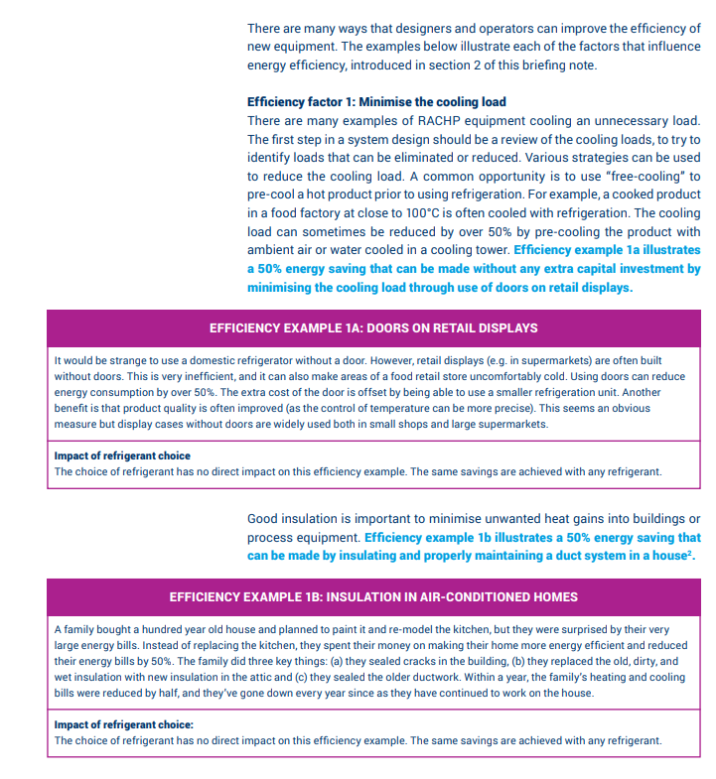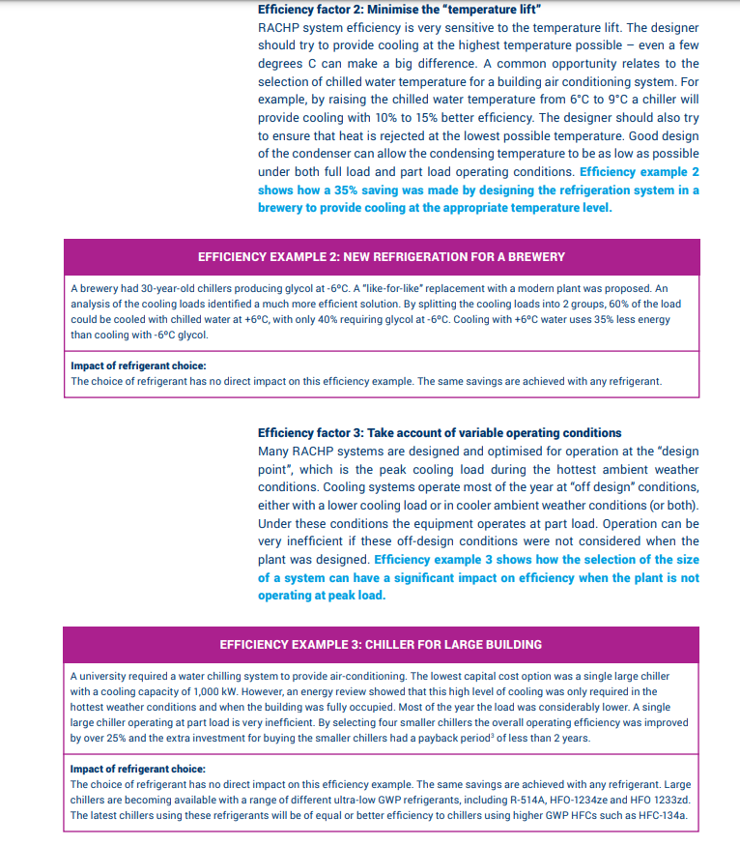

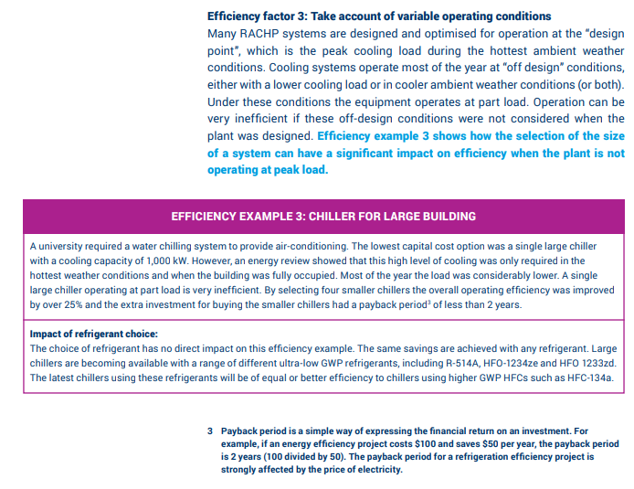

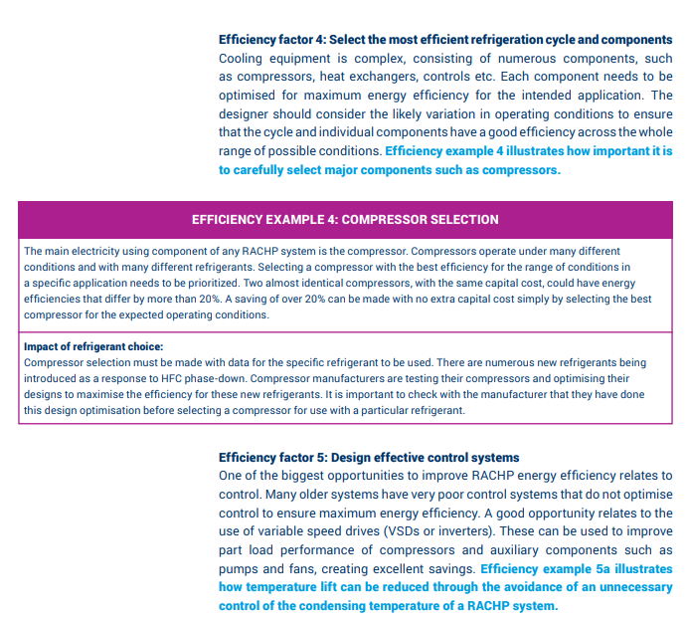

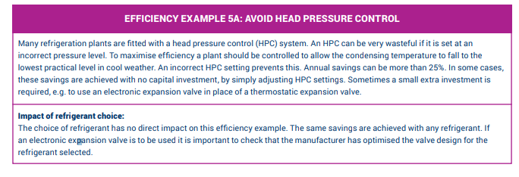

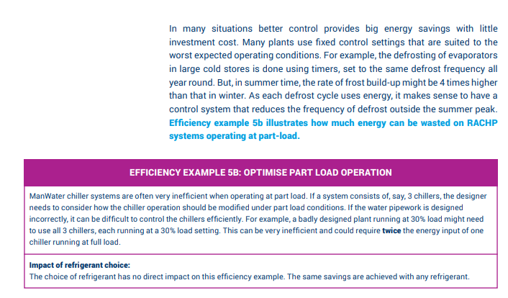

(UN Environment, 2018)

* Visit the full report for more information through this link:

https://ozone.unep.org/sites/default/files/2019-08/briefingnote-b_potential-to-improve-the-energy-efficiency-of-refrigeration-air-conditioning-and-heat-pumps.pdf

# **Appendix III – Invoices of Veal Fine**

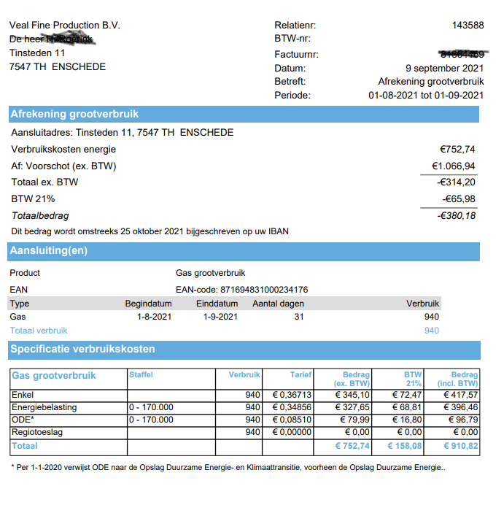

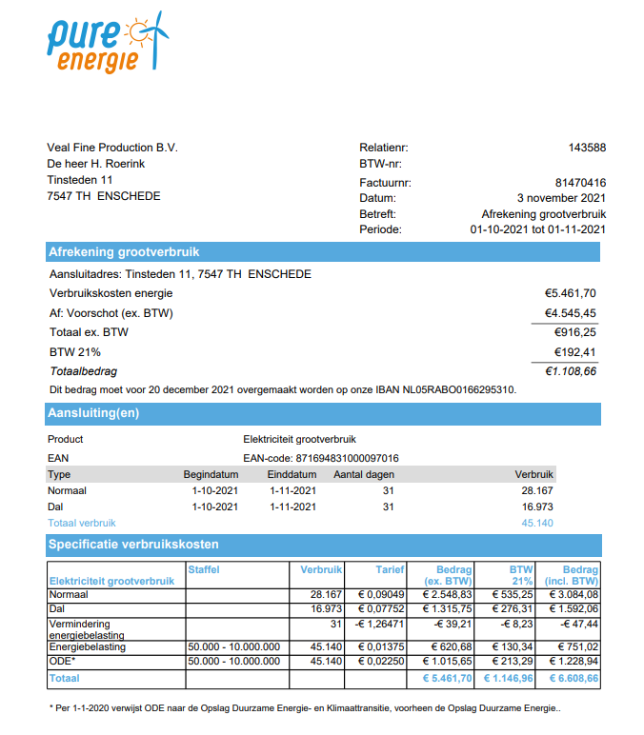

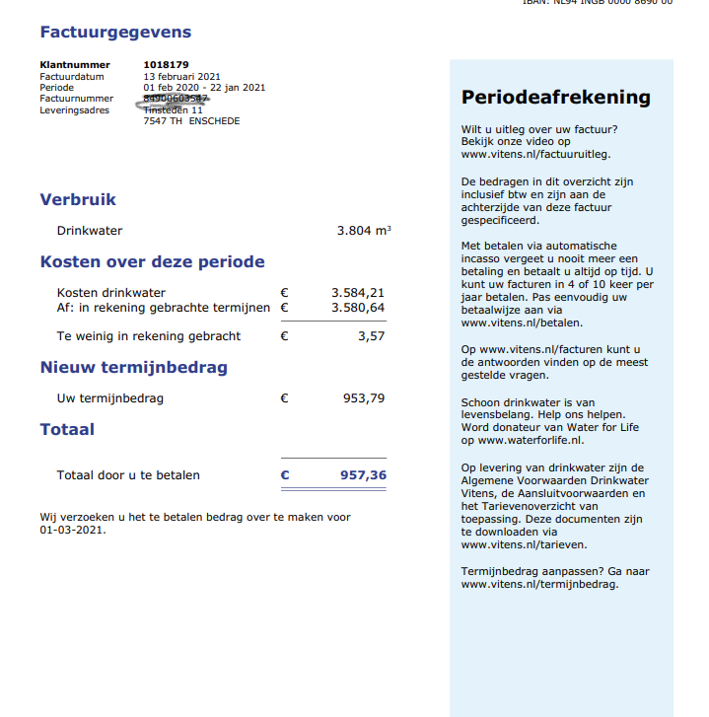

(van Roekel, Blackboard, 2021)

# **Appendix IV – Quickscan**

|  |  |  |  |  |
| --- | --- | --- | --- | --- |
| **Student name(s)** | | C.G.A Knopper  J. Younan  N. Lufting  R. van Munster  R. Younan  T. Phan | **Module** | Business Case  Veal Fine |
| **Student number(s)** | | (498985)  (494922)  (501963)  (494921)  (489906)  (487138) | **Date** | 17-01-2022 |
|  | **Requirements** | | **Fulfilled √** | |
| 1. | The document is a PDF file and saved as:  studentnumber_studentname_assignment_date.pdf  (Add group number (and names) for group work) | |  | |
| 2. | The paper is written in correct language: spelling, grammar, and style, comprehensible for and tailored to the target audience | |  | |
| 3. | The paper has a neat lay-out: 10/12, Calibri, Arial, Sans serif, or Lucida sans Unicode, page numbering, 1.5 line spacing, consistent paragraph and header style, only images relevant to the content | |  | |
| 4. | The paper adheres to APA rules for:   * in-text references and bibliography * tables and figures * appendices | |  | |
| 5. | The paper complies with the assessment criteria as stipulated in the assignment:   * all required elements are present and in the right order, starting with the cover * the report meets the length requirements (page or word count) | |  | |
| 6. | The title page contains:   * Title (subtitle) * Full name(s) of author(s) (e.g. J.H. Johnson) * Student number(s) of the author(s) plus group number if applicable * Module name, assignment name, version number * Date of submission (day, month, year) | |  | |
| 7. | The paper is my/our intellectual property and is therefore no infringement of anyone’s copyright. All sources used (including websites) have been referred to. The paper does not include more than 5% of any other parties’ excerpts. All team members contributed equally to the product and process. | |  | |
| 8 | Signature(s):    C.G.A. Knopper:      J. Younan:    A pair of glasses  Description automatically generated with low confidence  N. Lufting:  A picture containing porcelain  Description automatically generated  R. Younan  Diagram, engineering drawing  Description automatically generated  R. van Munster  A picture containing wire, line  Description automatically generated  T. Phan | | | |